

**Informatics Institute of Technology**

**Department of computing**

Bsc(Hons)Artificial Intelligence and Data Science

**Module: CM1605 Web Technology**

**Module coordinator:Ms.Janani Harischandra**

**Group Coursework Report**

* Tutorial Group : Group B
* Coursework Group No : Group 2
* 2119944 – 20210434 – A.J.Oshen Geenath
* 2119942 – 20210167 – J.P.V.Ronath Jayasuriya
* 2119943 – 20210164 – J.A.S.T.Jayakody
* 2117644 – 20210657 – Romal Lokubalasuriya

# 

# Index

Contents

Index 2

1.Introduction 3

2.Research on existing systems 4

Daraz 4

eBay 5

3.Technical Discussion 6

Student 01 – Vinuwara Ronath Jayasuriya 6

Student 02 – A.J.Oshen Geenath 15

Student 03 – Senesh Jayakody 34

Student 04 – Romal Lokubalasuriya 52

4.Discussion of UX/UI principles/Applications/Justifications 56

4.1 Navigation Techniques 56

4.2 Colour balance/selection/consistency 60

4.3 Colour Contrast Test 64

4.4 Typography / consistency 66

4.5 Accessibility 69

4.6 Accessibility Test 70

4.6 Site Diagram 71

5.Self-Reflection 72

6.References 73

7.Appendix 74

# 1.Introduction



BuyAnything.lk is an Sri Lanka based multinational e-commerce corporation Located at World Trade Center,1 Bank of Ceylon Mawatha, Colombo that facilitates consumer-to-consumer and business-to-consumer sales through its website. BuyAnything.lk was founded by Sumathi paala Aberuwan in 2020. BuyAnything.lk is a business with operations in about 12 countries, as of 2022. This website enables people and businesses buy a wide variety of goods and services worldwide. This website is made up of small businesses in Sri Lanka and other locations, It is the most visited e-commerce website in Sri Lanka in 2022.

1. Vinuwara Ronath - 2119942 - Student 1

* Create Account
* Presentation page
* Account Login
* Gallery

1. Oshen Geenath - 2119944 - Student 2
   * Home page
   * Navigation Bar
   * Quiz
   * Rate us
2. Senesh Jayakody- 2119943 - Student 3

* Purchase
* About Us page

1. Romal Lokubalasuriya - 20210657 - Student 4

# 2.Research on existing systems



## Daraz

Daraz is one of the biggest e-commerce platforms that offer users a virtual shopping mall where you can browse and shop through more than 2 million products of assorted categories. When a customer orders an object from Daraz the customer has the ability to go pick it up from a main office or get it delivered straight to their house .

* The most popular e-commerce site in Sri Lanka.
* When a customer order an item a person from their courier service would deliver it to the house.
* Has the ability pay cash on deliver or in instalments which is a plus compared to international e-commerce websites.



## eBay

eBay Inc. is an American multinational e-commerce corporation based in San Jose, California, that facilitates consumer-to-consumer and business-to-consumer sales through its website. eBay was founded by Pierre Omidyar in 1997, and became a notable success story of the dot-com bubble.

* eBay has the ability for multiple customer to bid on an item in order to buy that item.
* For the people who doesn’t want to bid there are items with fixed prices.
* Items which has been bought would be sent through the postal service or through a courier service.
* Currently there are 159 million active customer bas
* Has the ability to pay using a credit/debit card or PayPal.
* Has an algorithm which would display items to buy according the users search preferences.

# 3.Technical Discussion

## Student 01 – Vinuwara Ronath Jayasuriya

* A presentation page with title and the name of people in the group. After 5 seconds, a second page will be displayed (Main Web page).

This was achieved by using the tag



In the head tag. Which would allow to the html to show the list of the people names for five seconds then redirect to the create account html

As for the list Student 1 used individual paragraph tags to represent each group members Therefore, it would be easier to centre all the names on the website.

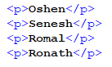

* The website should contain a signup form to enter the details of the user which is required to generate the personalized results depends on the chosen topic. This should include

Personal Details (Name, Age, Gender, Occupation, Email etc) – 5 compulsory criteria

Student 1 Used the forms tags such as

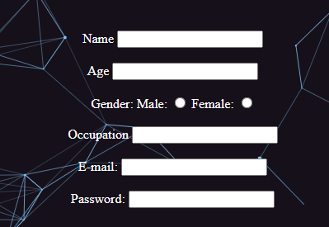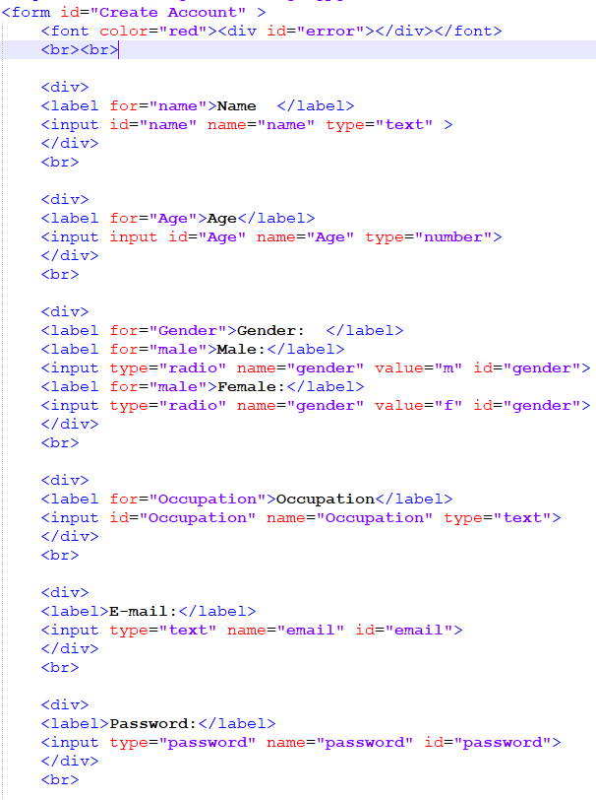

* At least 3 different compulsory criteria to check the user’s preferences ( Eg: Educational Brand, Features, Type depends on the chosen topic)

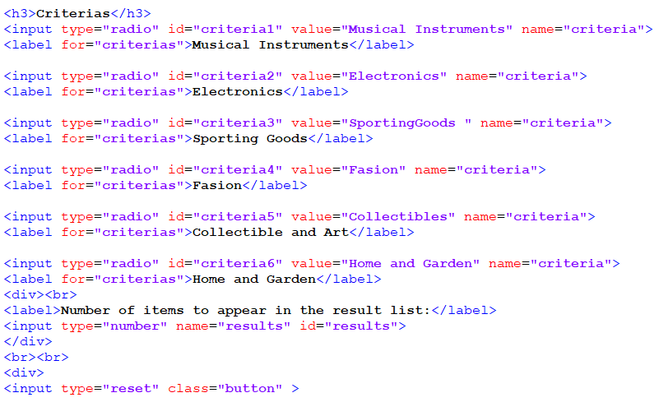



* No of items to appear in the result list

As above student 1 used form tag





* Use JavaScript validation to check that the user has filled-in 5 compulsory personal detail fields chosen in b).1 -, 3 compulsory user preferences and number of items in the result list. Do NOT use HTML5 validation for this part. (If HTML5 validation used zero marks will be awarded)

Used java script to show error if data was not entered.

Linked the script



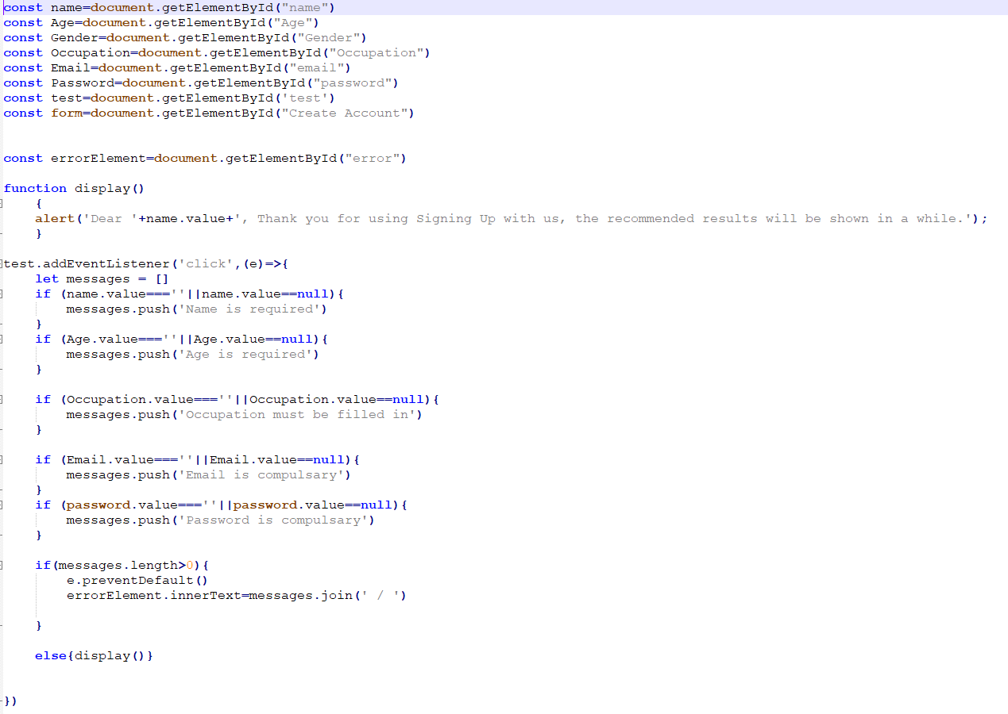when pressing submit button red error would be displayed

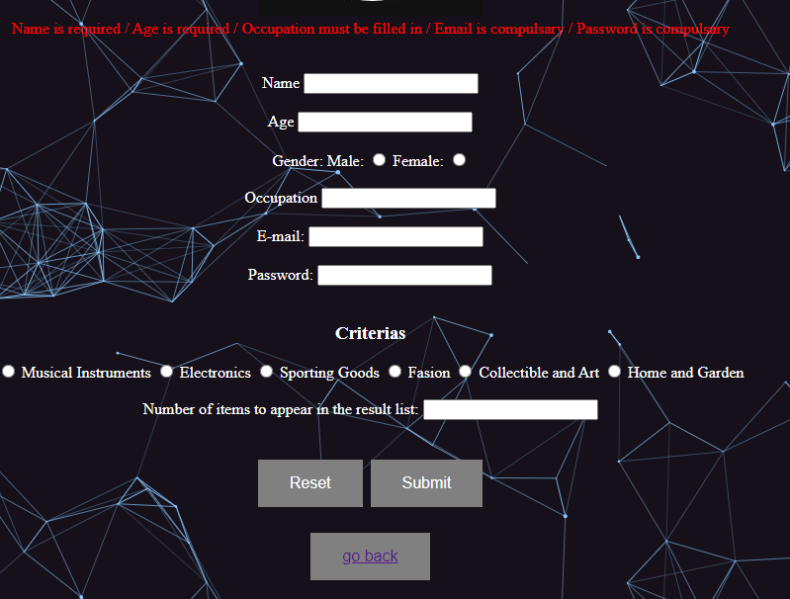

* If all compulsory fields are filled an alert should be generated to indicate the information submitted successfully. The pop up summary should contain "Dear Anna, Thank you for using Signing Up with us, the recommended results will be shown in a while.”



According to the users name a pop up would be displayed as showed in display();

* Create gallery page that allows the user to view images. This page contains 5 thumbnail images and an area to display a larger image and associated description of that image. When the user selects a thumbnail image, the corresponding large image and the description of that image should display in the defined location on the form. You may use onMouseOver or radio buttons to select the thumbnail. (The images will be related to the topic you choose Eg: if you’re developing the Job recommendation system, this could be different company profiles etc.)

Inserting images



Used javaScript to maximize image and display text when the mouse hover over the image

Five copies of this code was used to represent all the five images

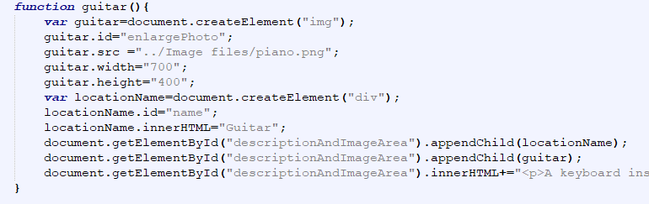

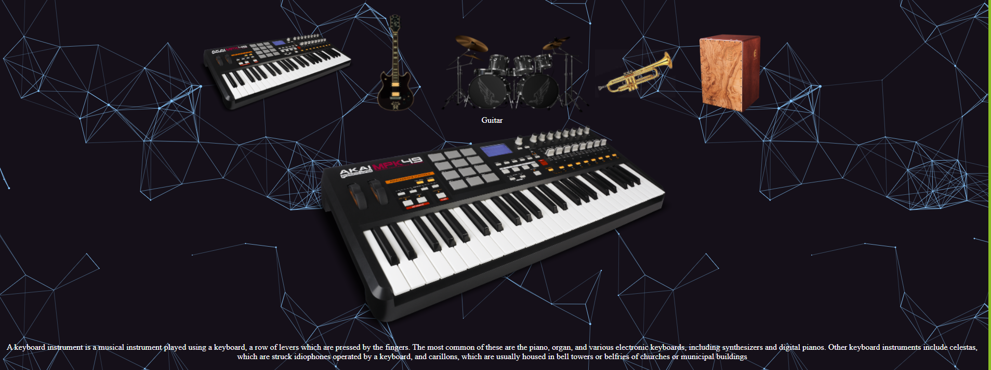

* Each page of the web site should include the title logo at the top, and a link to the page editor (the person who created the page) at the bottom of the page.

For the logo and background

For the footer

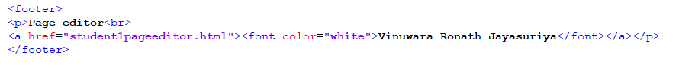

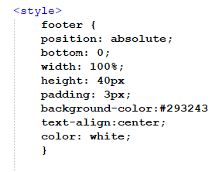

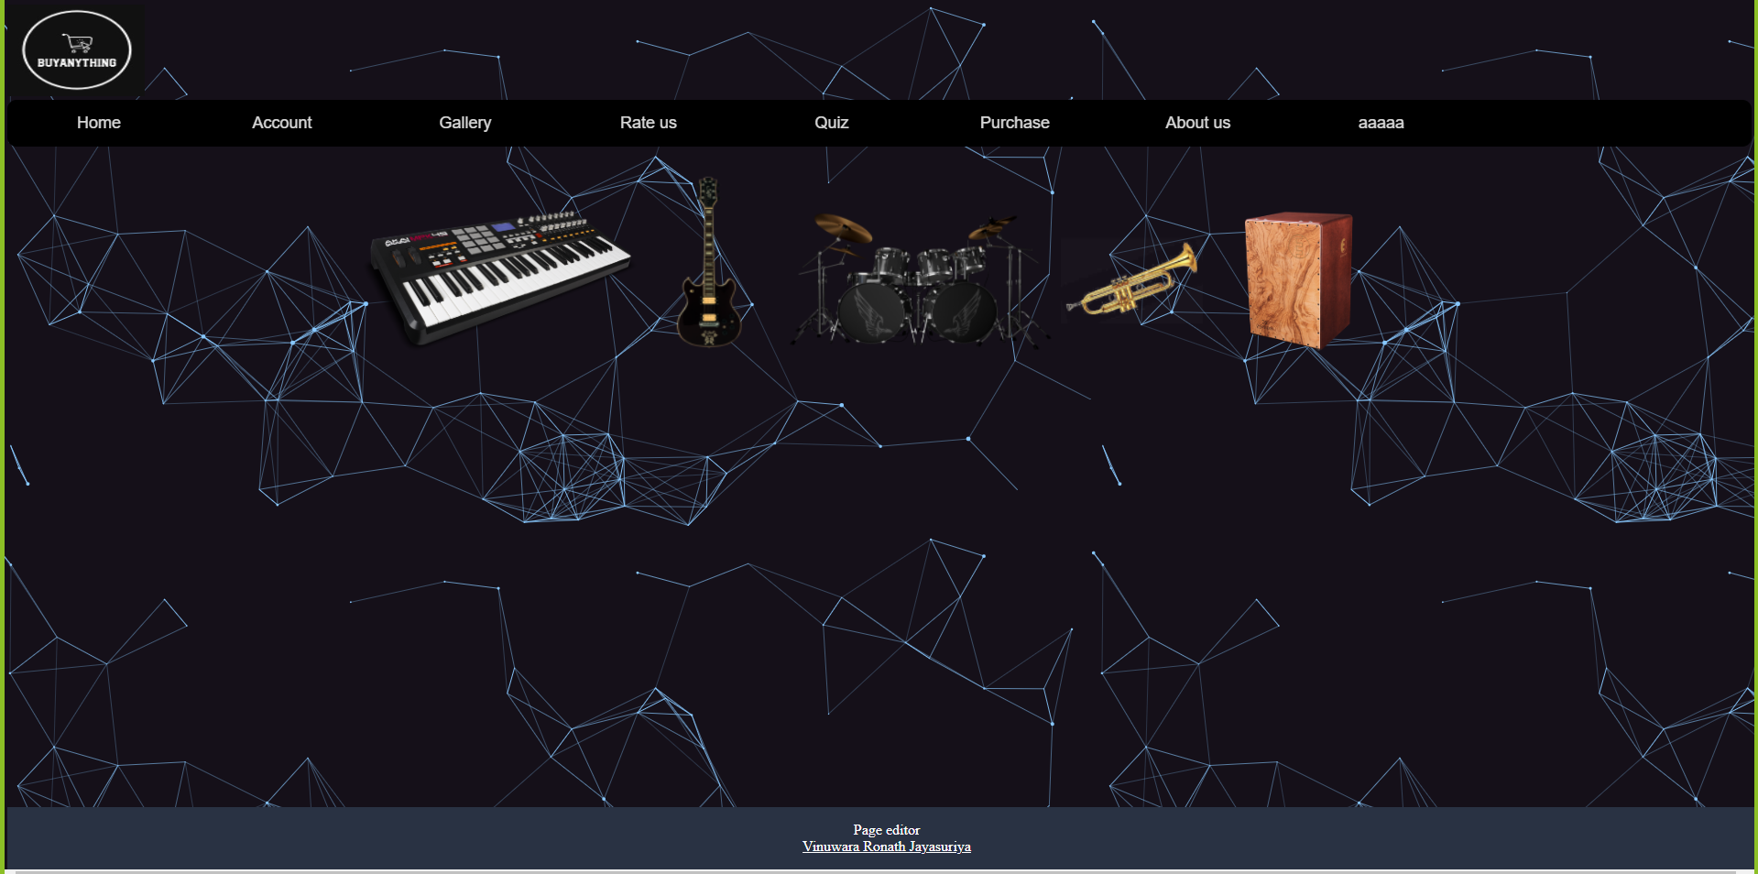

* Create editors page
* Linked all the websites that I created to the editors page

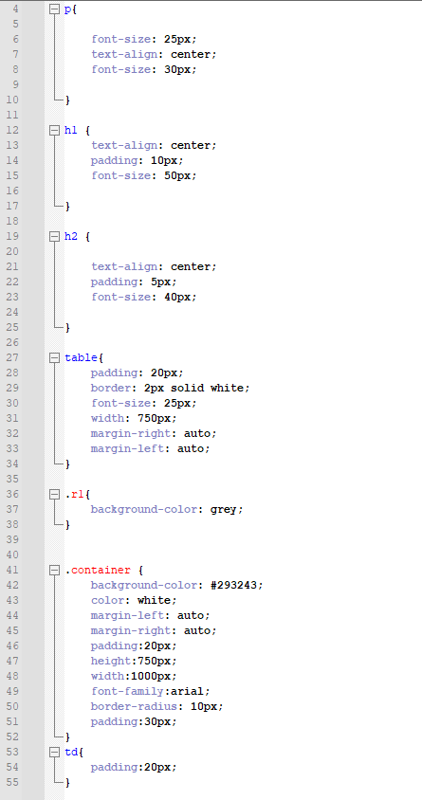

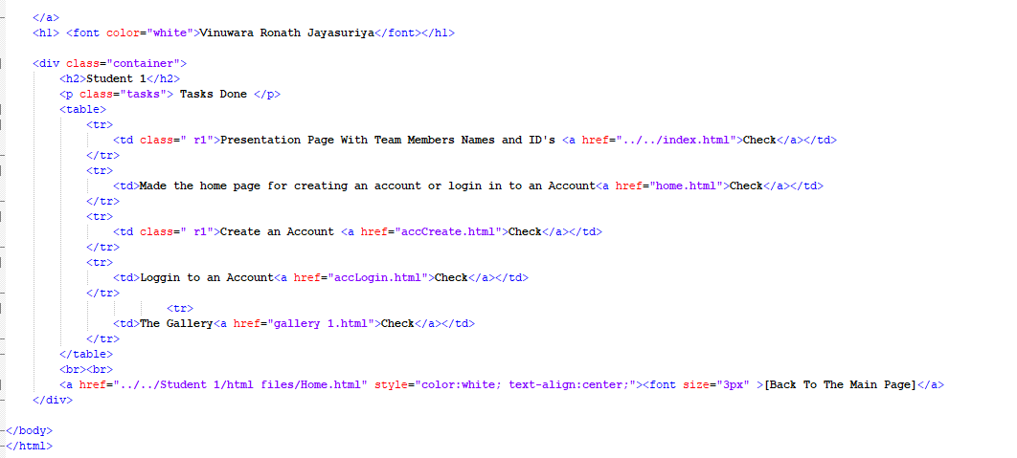

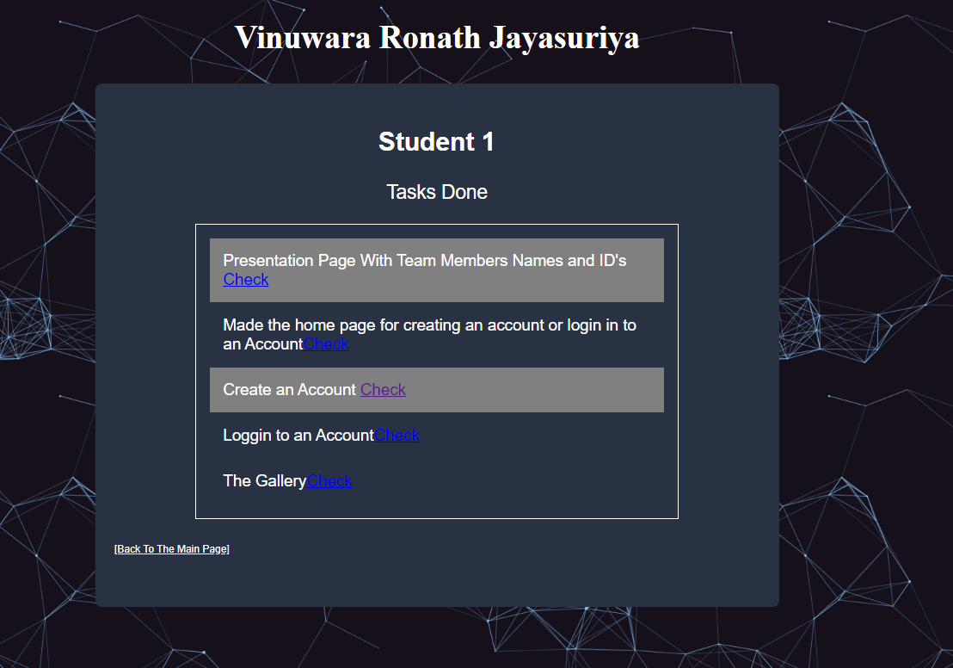

## Student 02 – A.J.Oshen Geenath

* The Main page should be designed in a way that the user can access several parts of the web site. The links on the main page should look like buttons and have a hover effect. This should be implemented using CSS.

The main page was designed in a way that the user can access all the parts of the website.

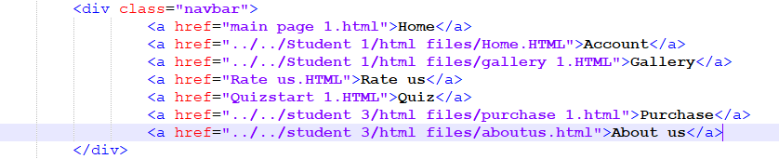

The main page was implemented with the buttons and it has hover effects using CSS.

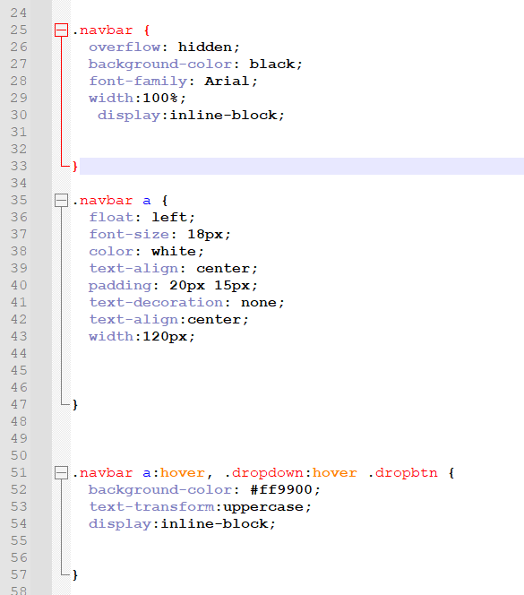

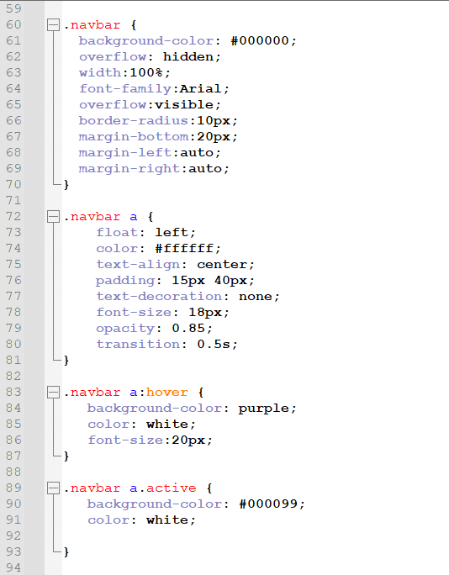

Linked the CSS file to the HTML file.



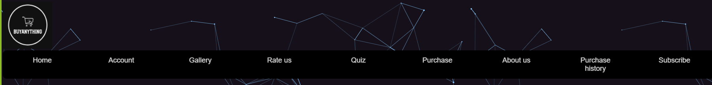

* The Main Page should contain a video related to the chosen topic (Eg: Trailer of a success story/website developed etc)
* According to the criteria which were chosen in the account creation different videos will be played. I created six main pages

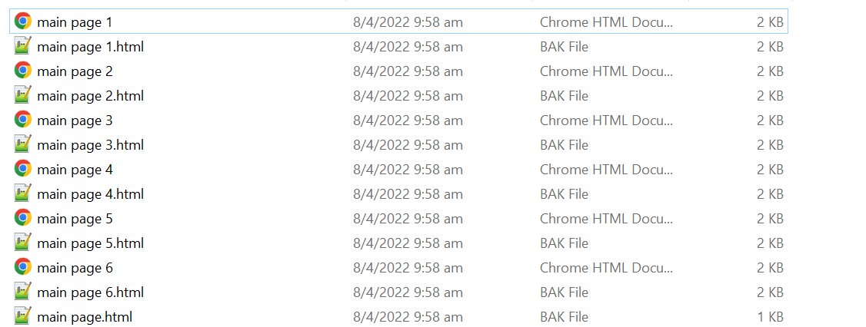

* Criteria 1 - Music Instruments

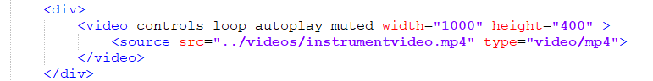

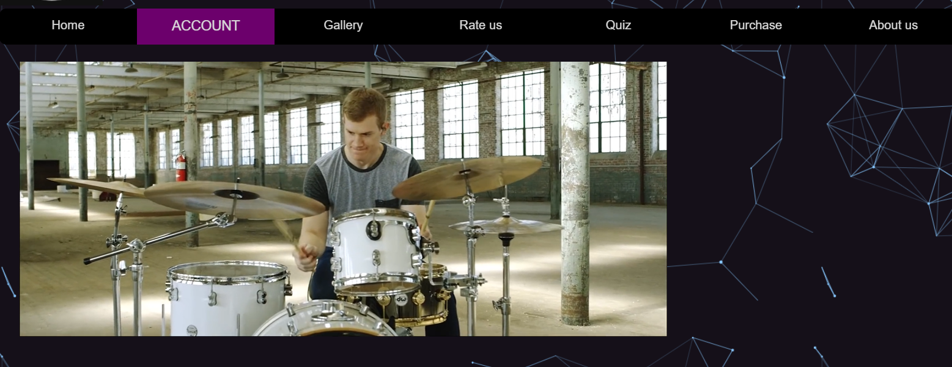

* Criteria 2 – Electronics

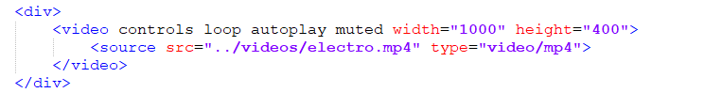

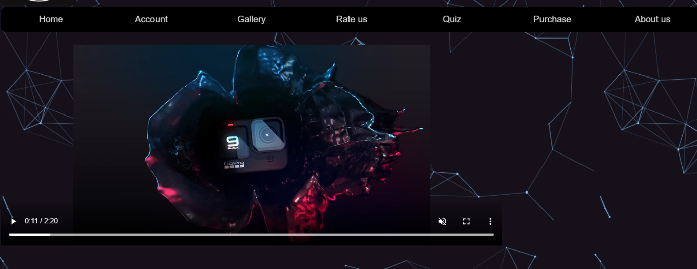

* Criteria 3 – Sports

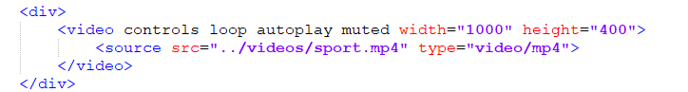

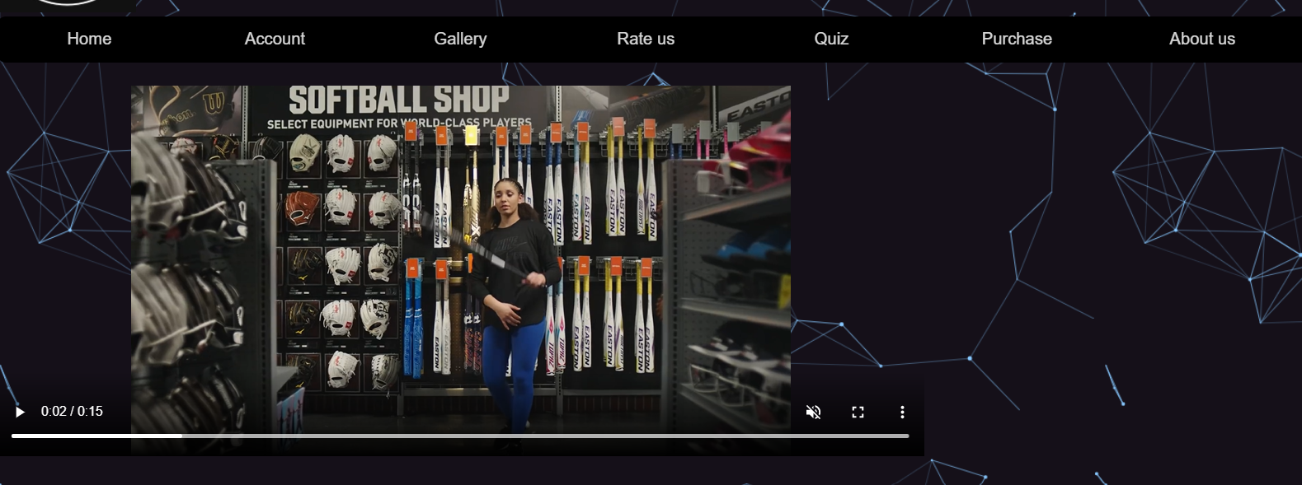

* Criteria 4 – Fashion

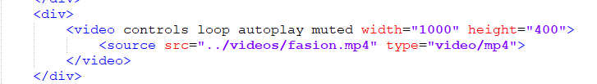

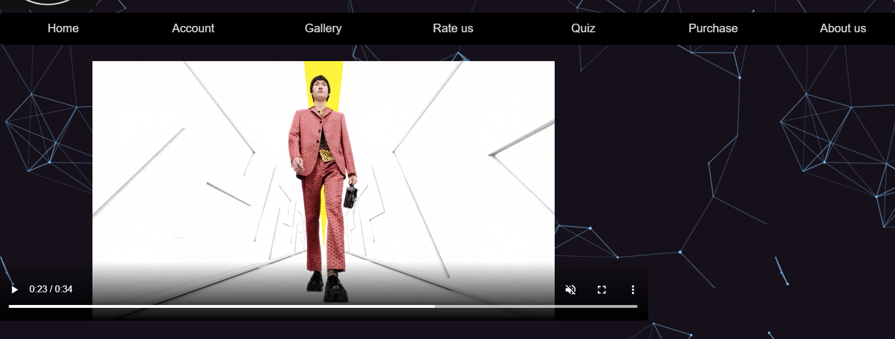

* Criteria 5 – Arts and Collections

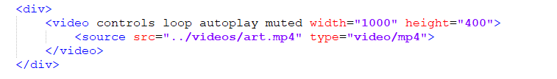

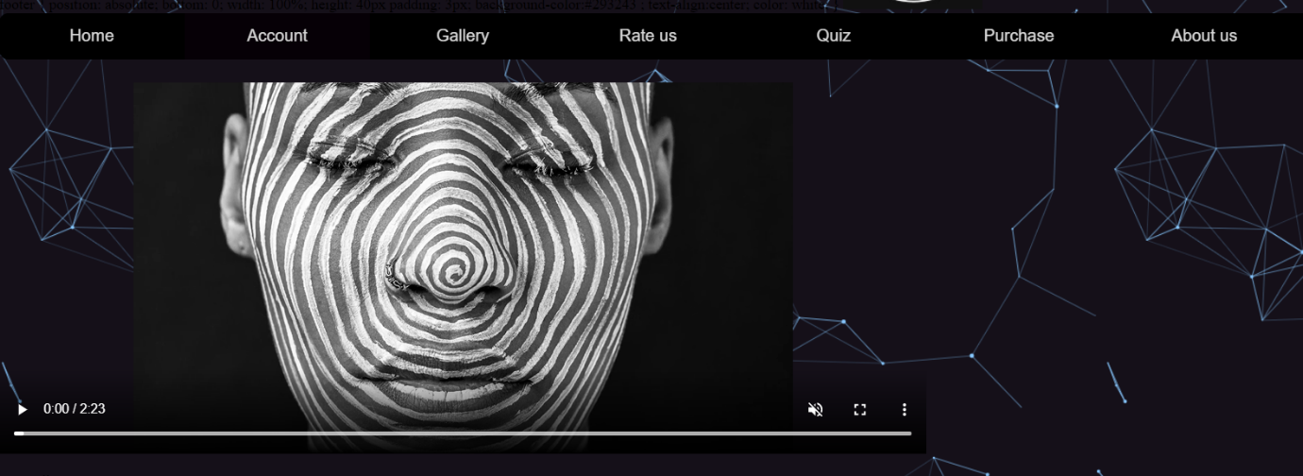

* Criteria 6 – Home and Garden

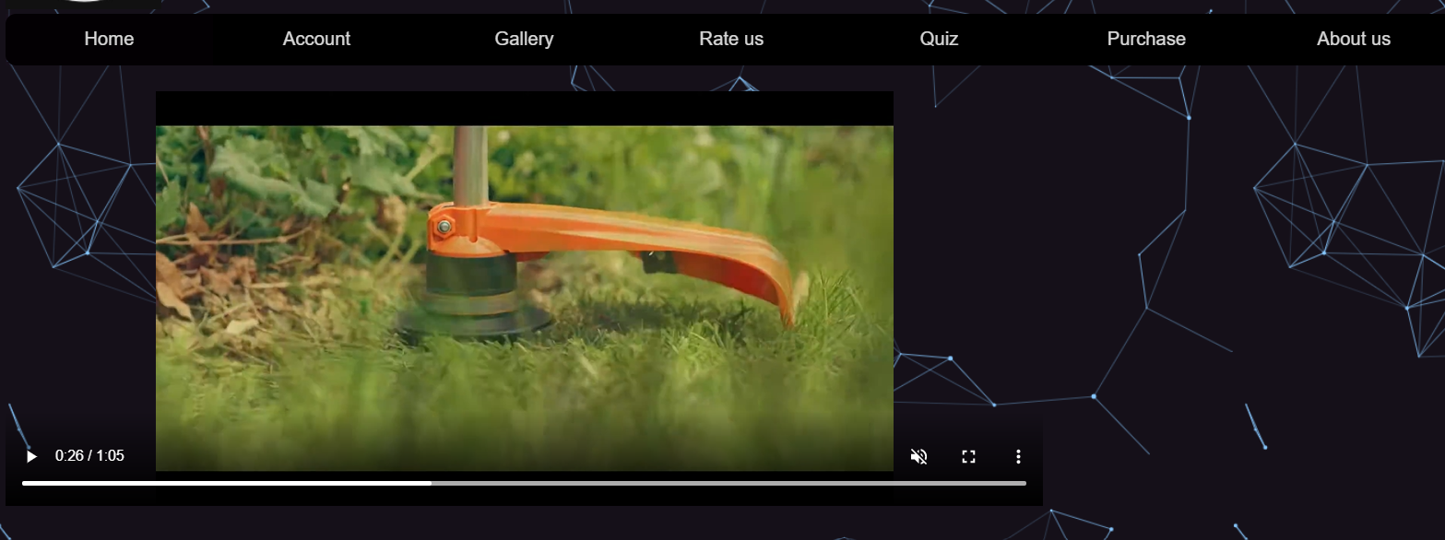

* Created a JavaScript file to choose the video according to the criteria

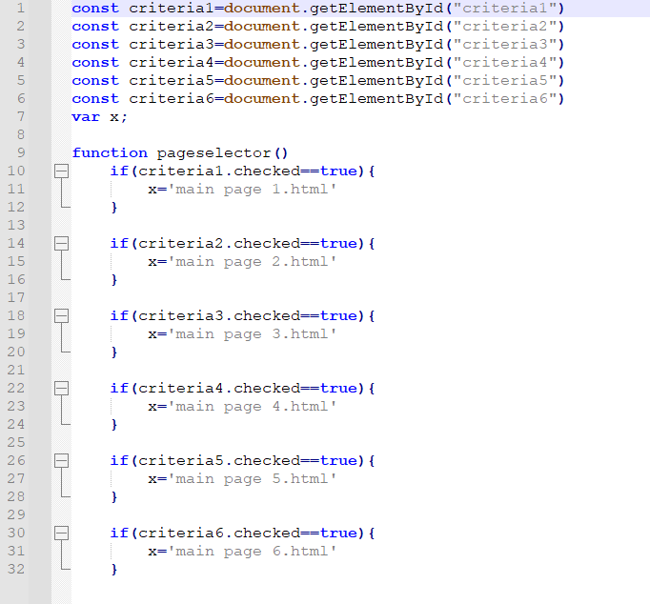

* The consistency of the style should be ensured using a unique external style sheet file. This will be used by the other members of the group though out the website. The style sheet should be created for

Main Page

Navigation

* Student 2 used Main page CSS to maintain consistency

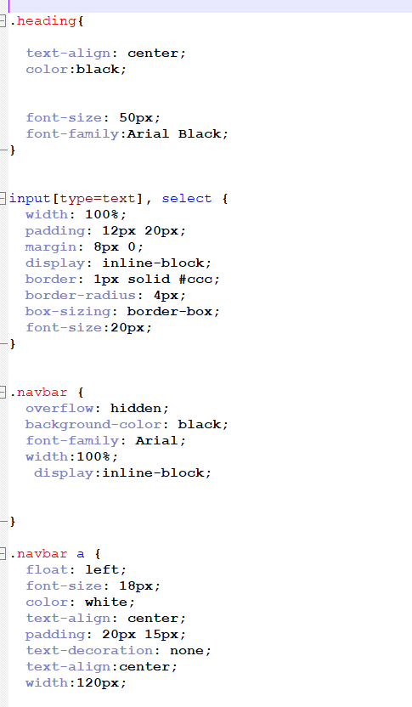

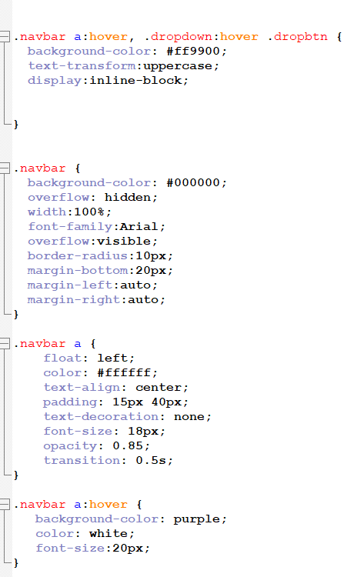

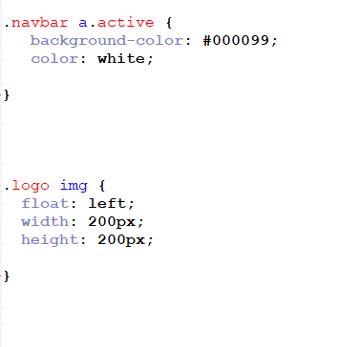

* The web site should contain a form to send comments about the web site. This form should include following.
* Form input fields for users to enter their details (name, email address)
* Used HTML to create input fields

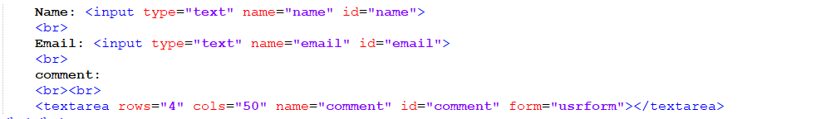

* A field to enter comments



* Option to rate the web site (using radio buttons or select)

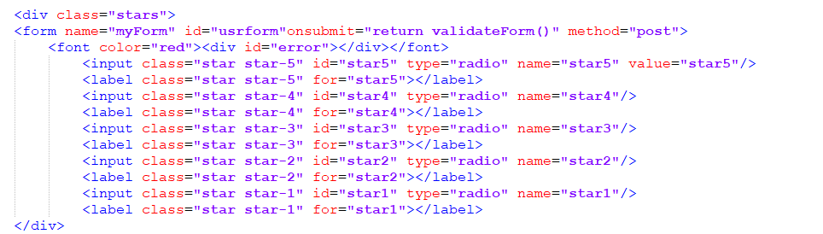

* Used CSS to make the option rate more interactive

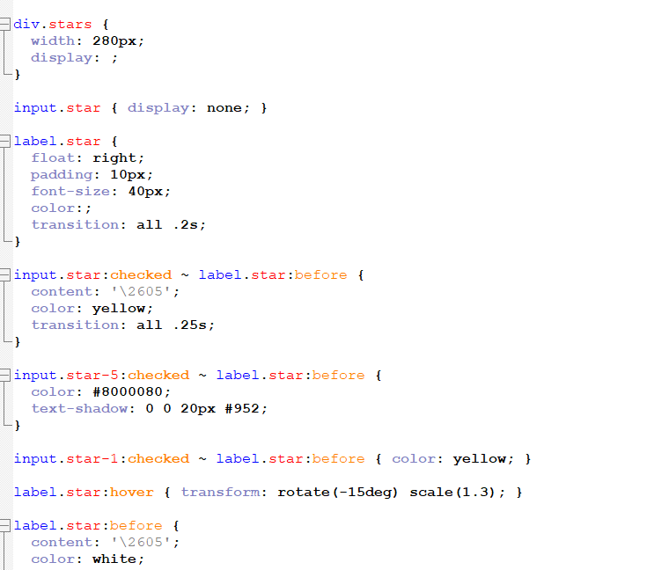

* A button to reset the forms. When reset button is clicked the form should be reset.

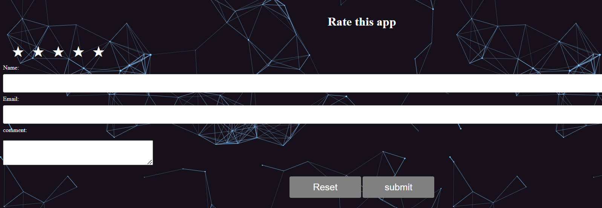

* The form should be validated using JavaScript validation to check that the user has filled-in the compulsory fields - 'name', ‘email’ and 'rating'. (If HTML5 validation used zero marks will be awarded)

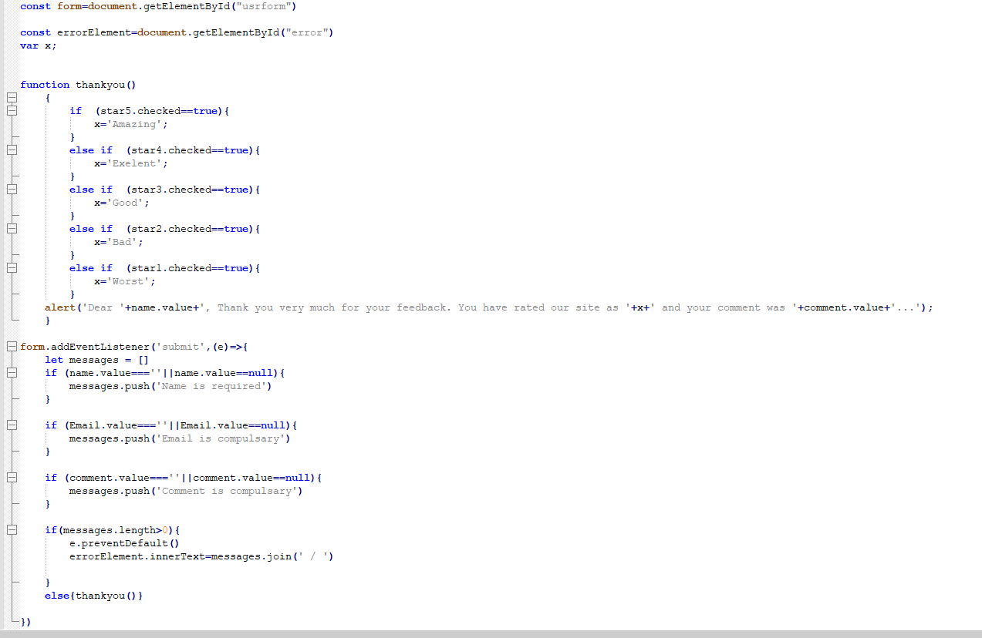

* 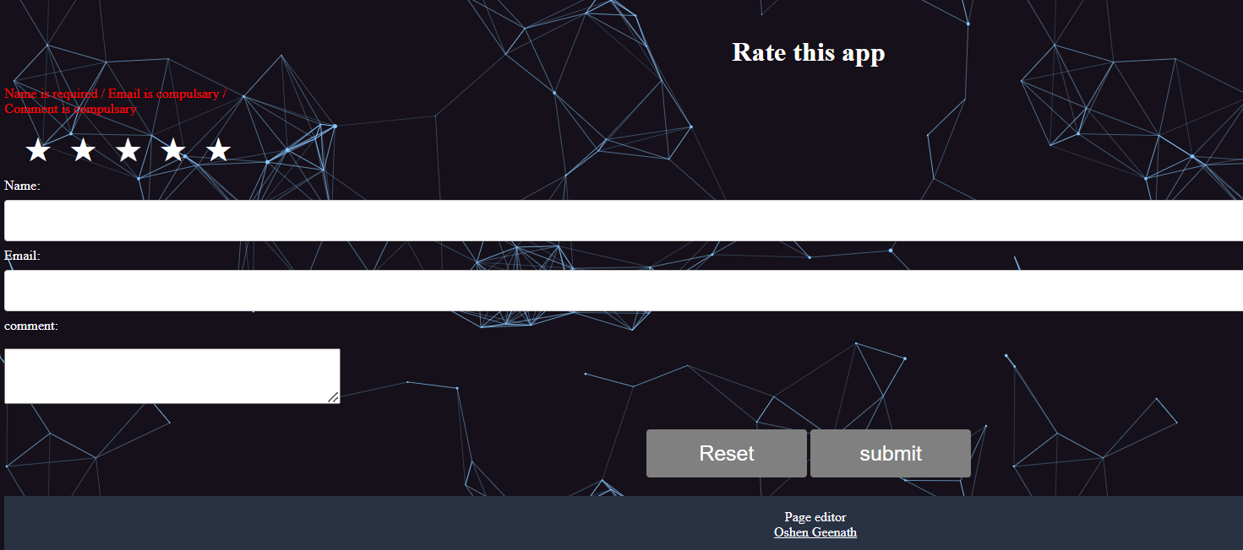If submit without Filling the criteria’s an error will be shown
* If the name, email and ratings are filled-in, the user should get an HTML popup window with the summary including the name, any comments and rating given on the form.
* The pop box should give the below message format if all compulsory fields are filled.
* Eg: if the user entered "Anna" for their name, rated the site as "good" and entered "Very informative website", "Dear Anna, Thank you very much for your feedback. You have rated our site as Good and your comment was Very informative website."

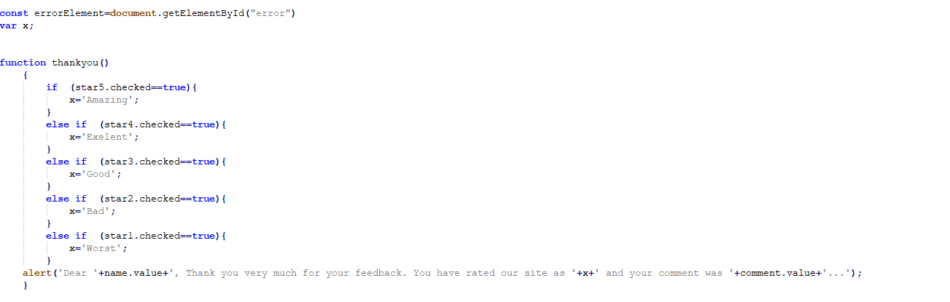

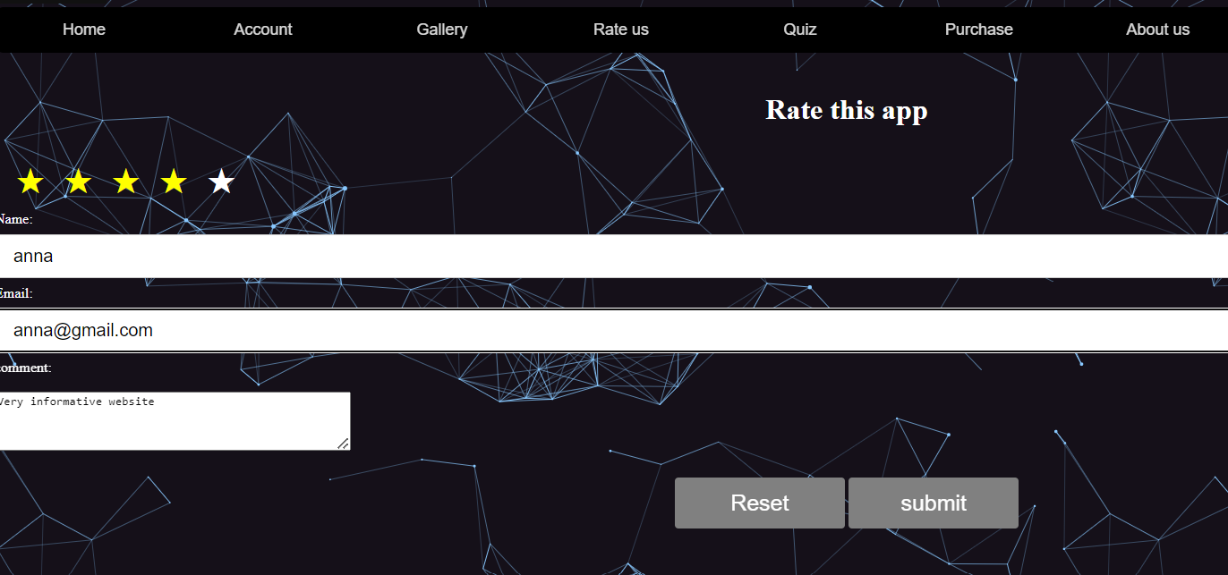

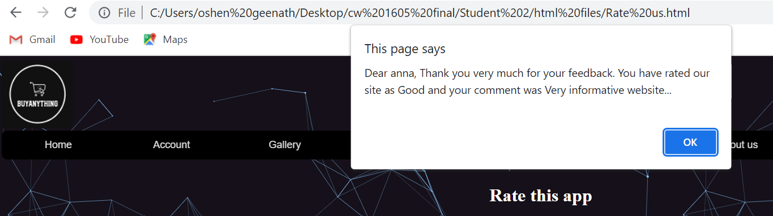

* A JavaScript quiz should be created to increase the user engagement of the website. The quiz should be implemented using JavaScript prompt box ().
* Made a page to show rules and regulations to show before the quiz start

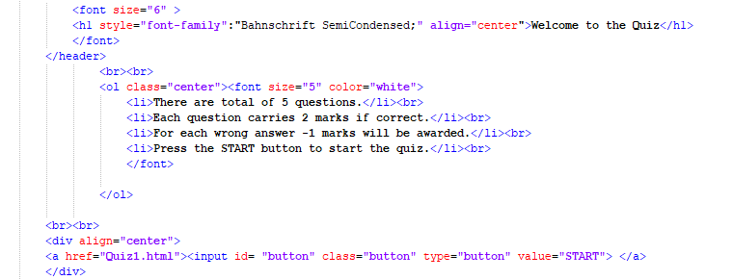

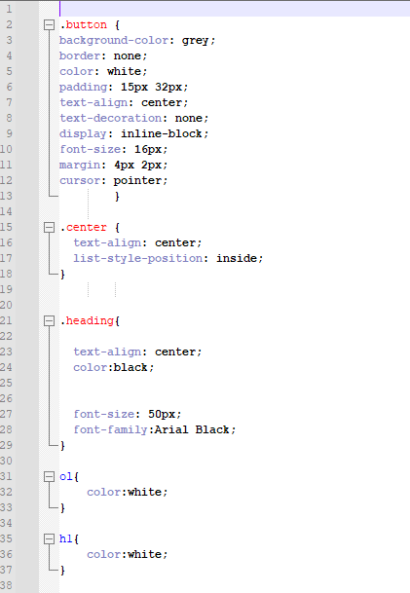

* According to the criteria which were chosen in the account creation different Quizzes will be displayed I created Quizzes.

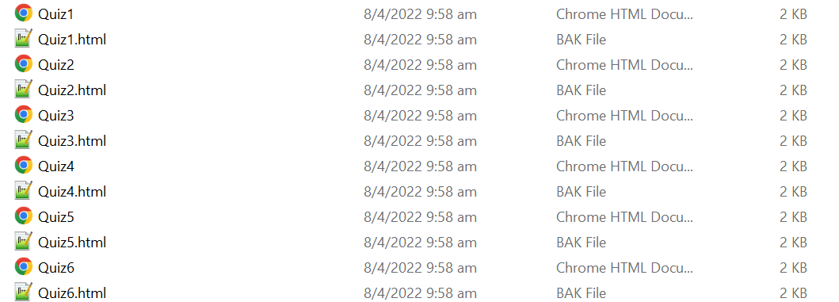

* It should contain 5 questions related to the topic chosen.
* 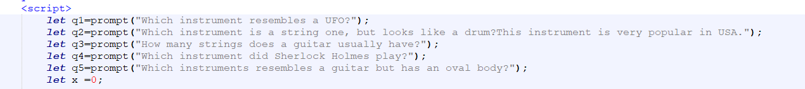Criteria 1 – Music Instruments
* 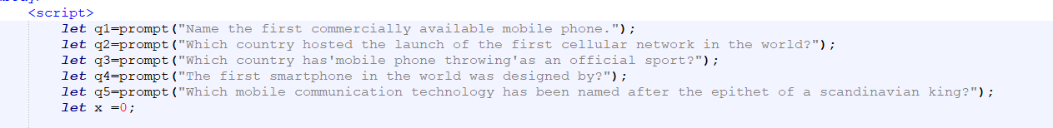Criteria 2 – Electronics
* Criteria 3 – Sports

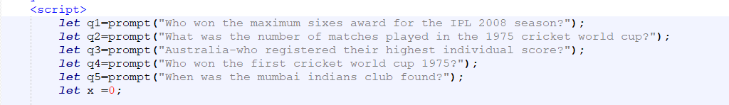

* 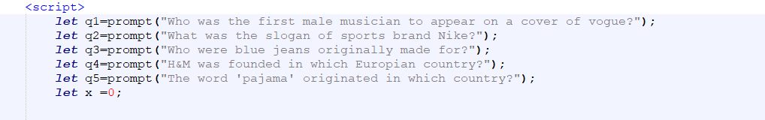Criteria 4 – Fashion
* Criteria 5 – Arts and collections

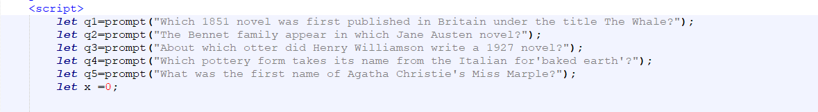

* 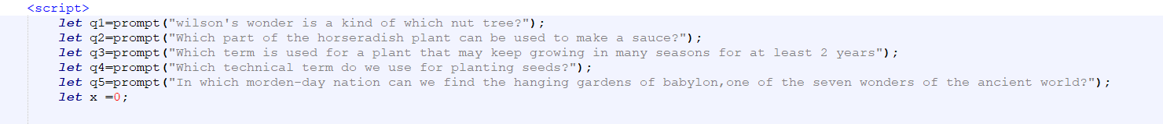Criteria 6 – Home and Garden
* Each question carries 2 marks and -1 for each wrong answer.

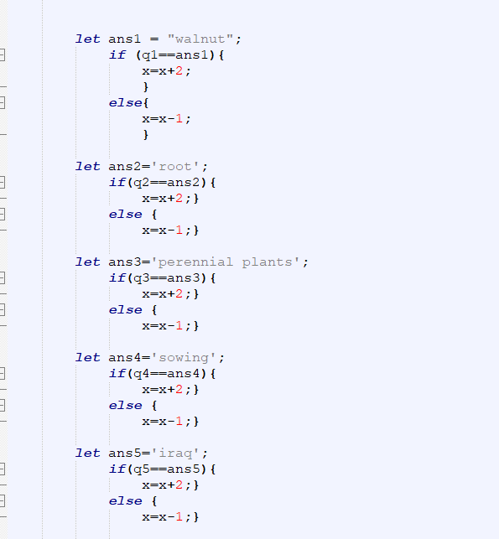

* The different badges (Gold, Silver, Bronze) will be awarded to users depending on their performance

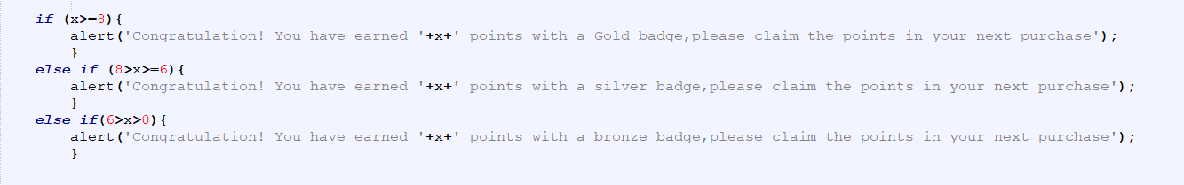

* When the quiz is completed users will be given the badge awarded with the points earned in a pop up box.
* The message should contain “Congratulation! You have earned 10 points with a Silver badge”, please claim the points in your next purchase”

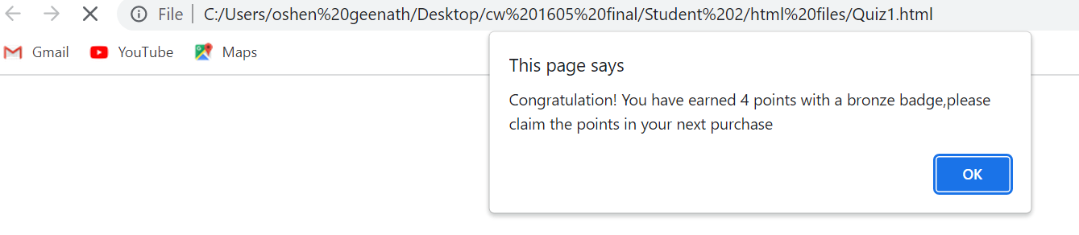

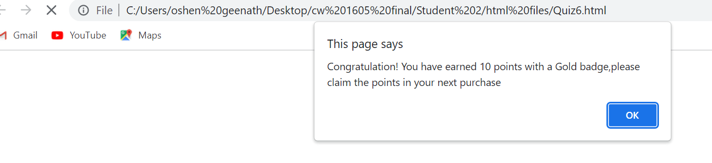

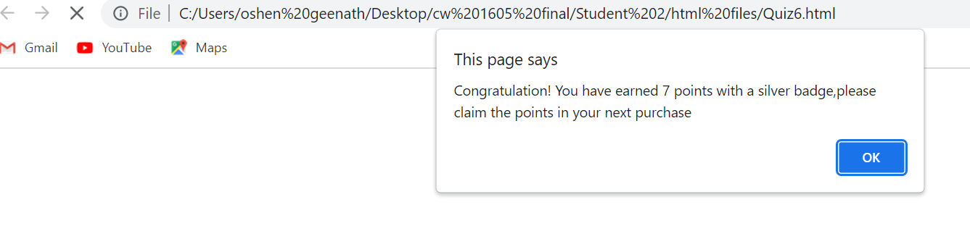

* Each page of the web site should include the title logo at the top, and a link to the page editor (the person who created the page) at the bottom of the page.
* For the logo and background



* For the footer

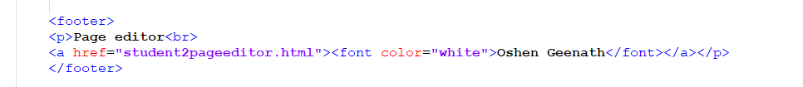

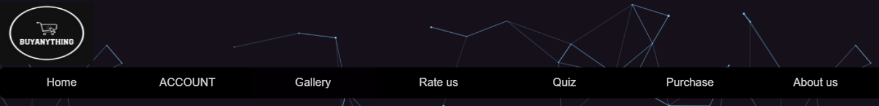



* Create editors page
* Linked all the websites that I created to the editors page

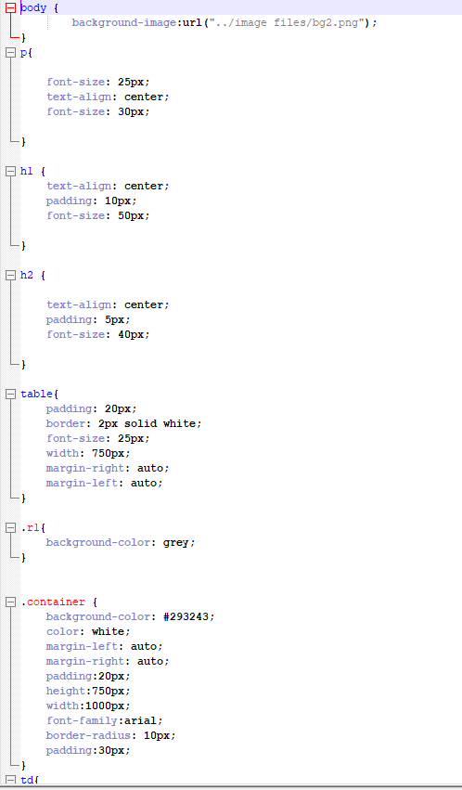

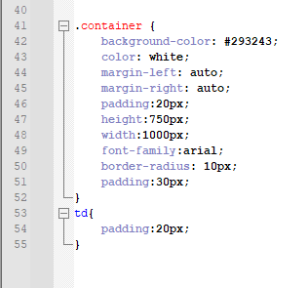

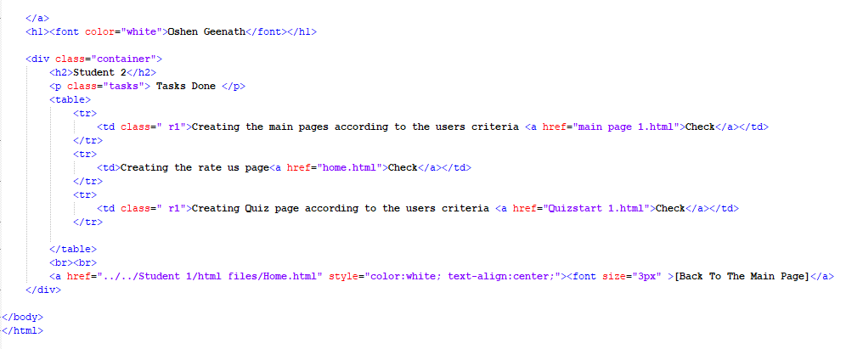

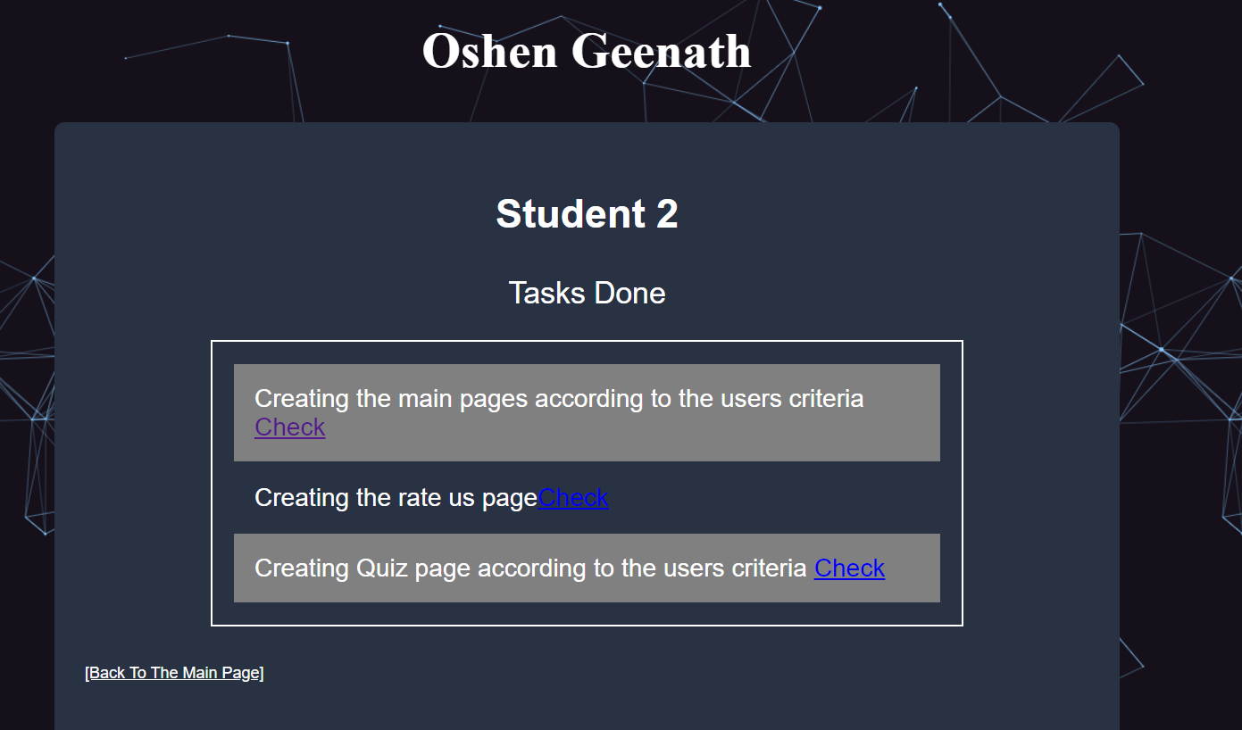

## Student 03 – Senesh Jayakody

The website should contain a page to buy products according to the criteria

Since there are six criteria, and the user would only select one student 3 made six perches HTML for each criteria.

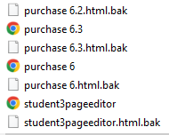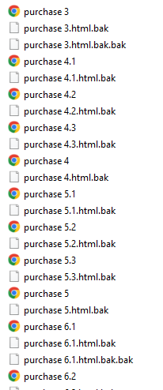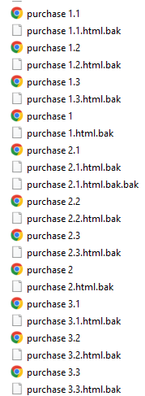

* Criteria 1 – musical instruments 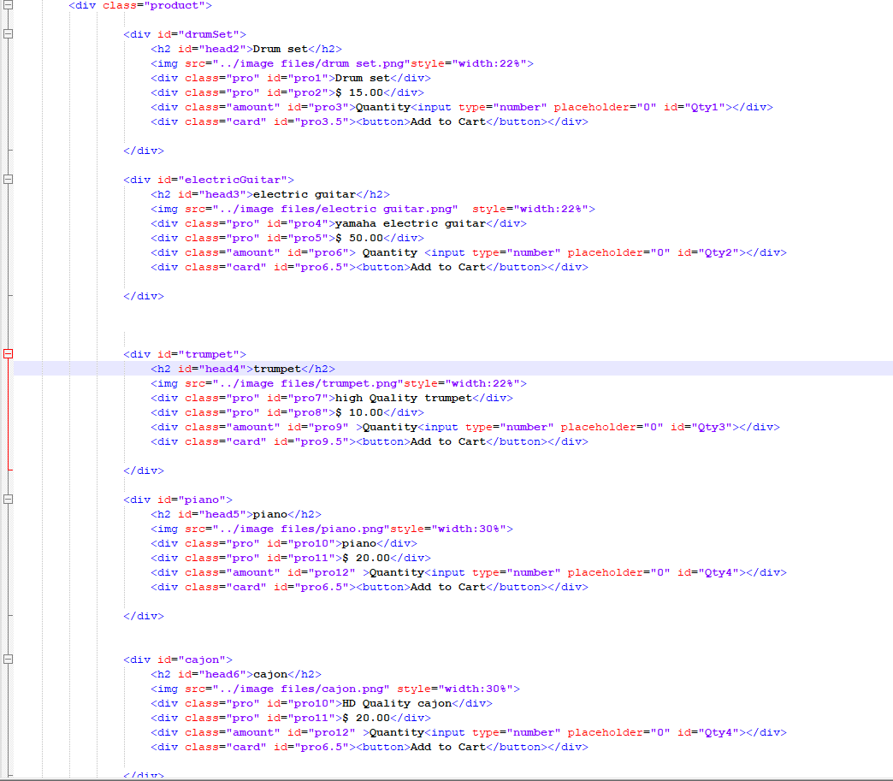

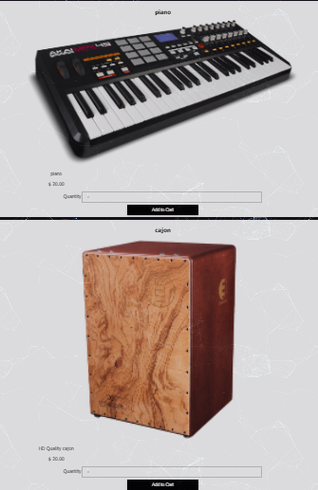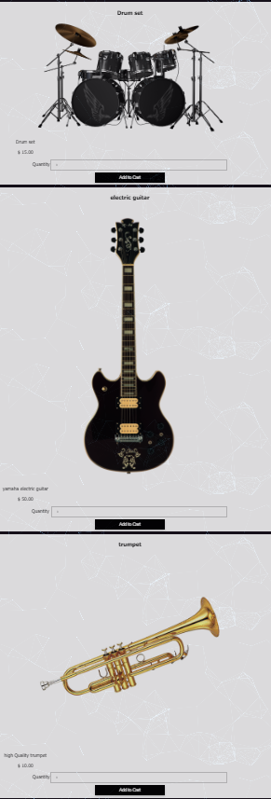

* Criteria 2 – Electronics

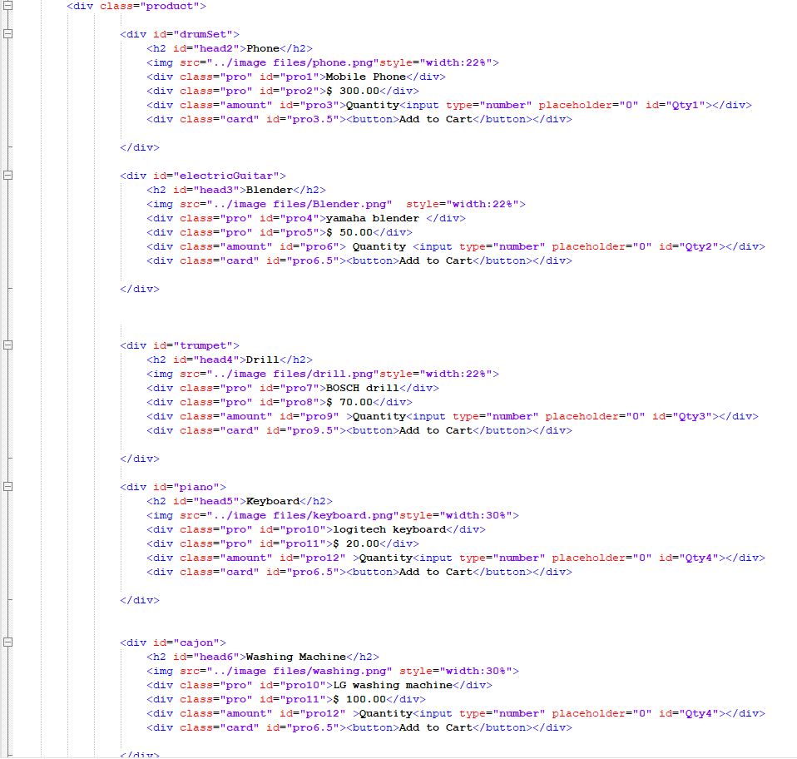

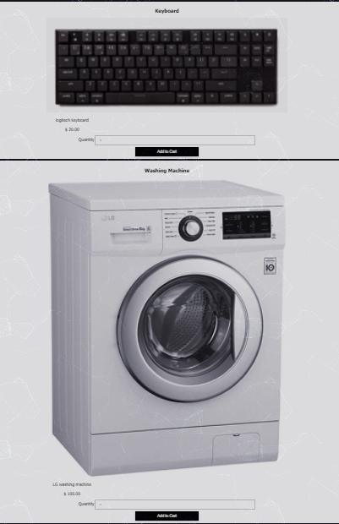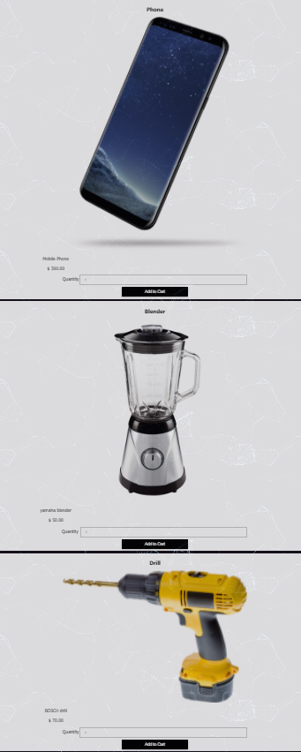* Criteria 3 – Sporting GoodsGoods

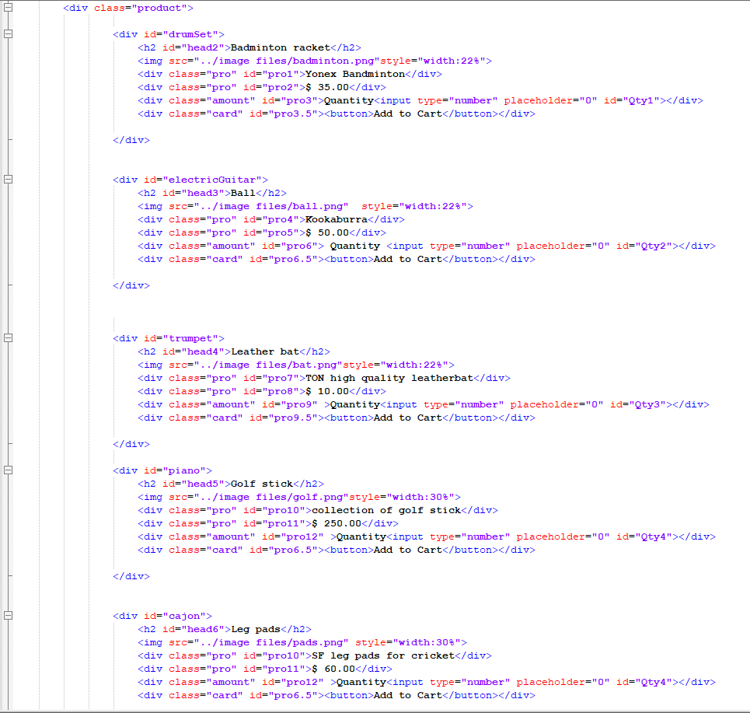

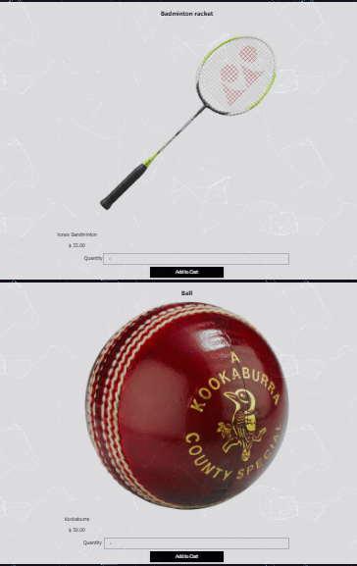

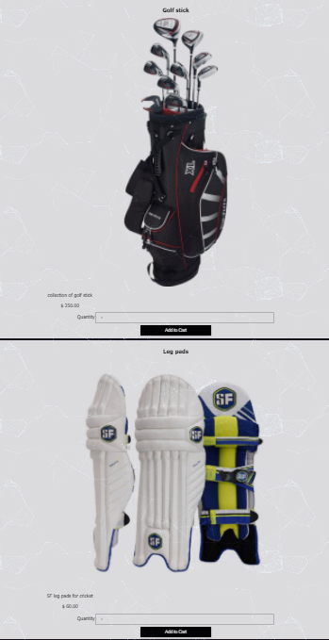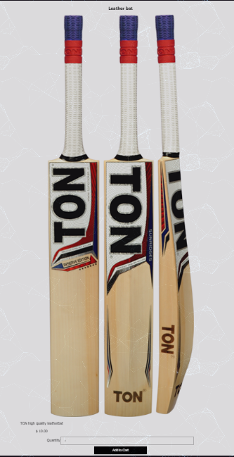

* 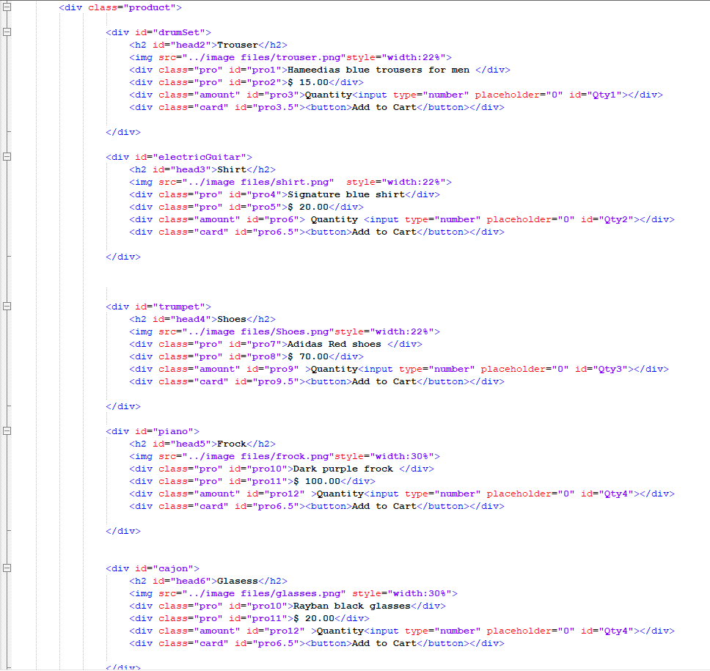Criteria 4 - Fashion

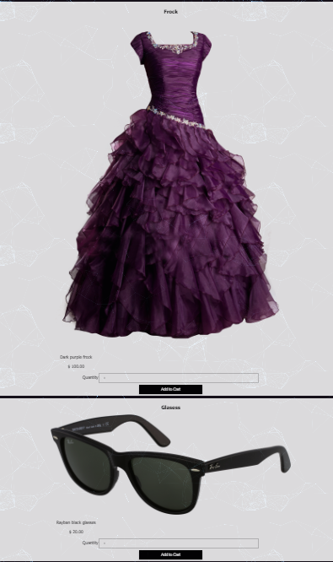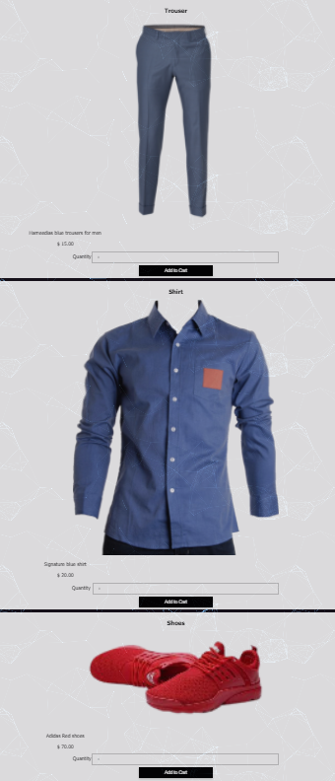

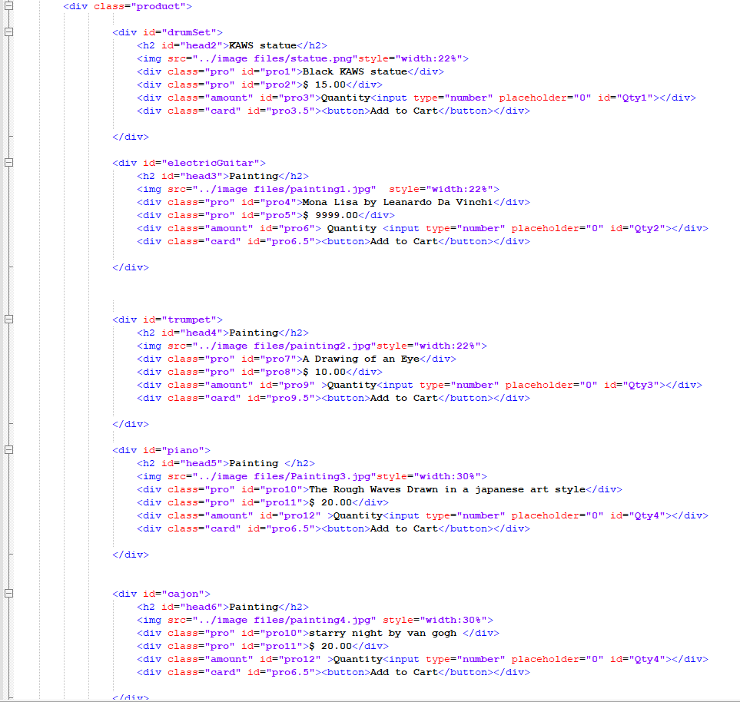Criteria 5 – Collectible and arts

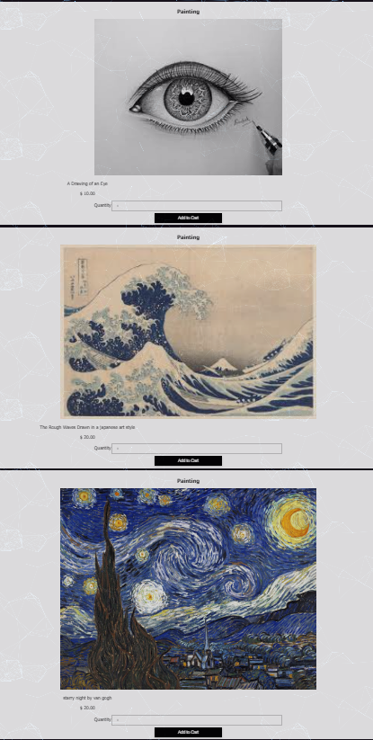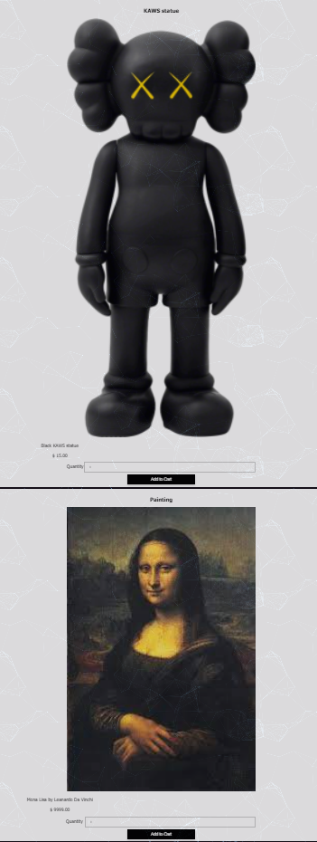

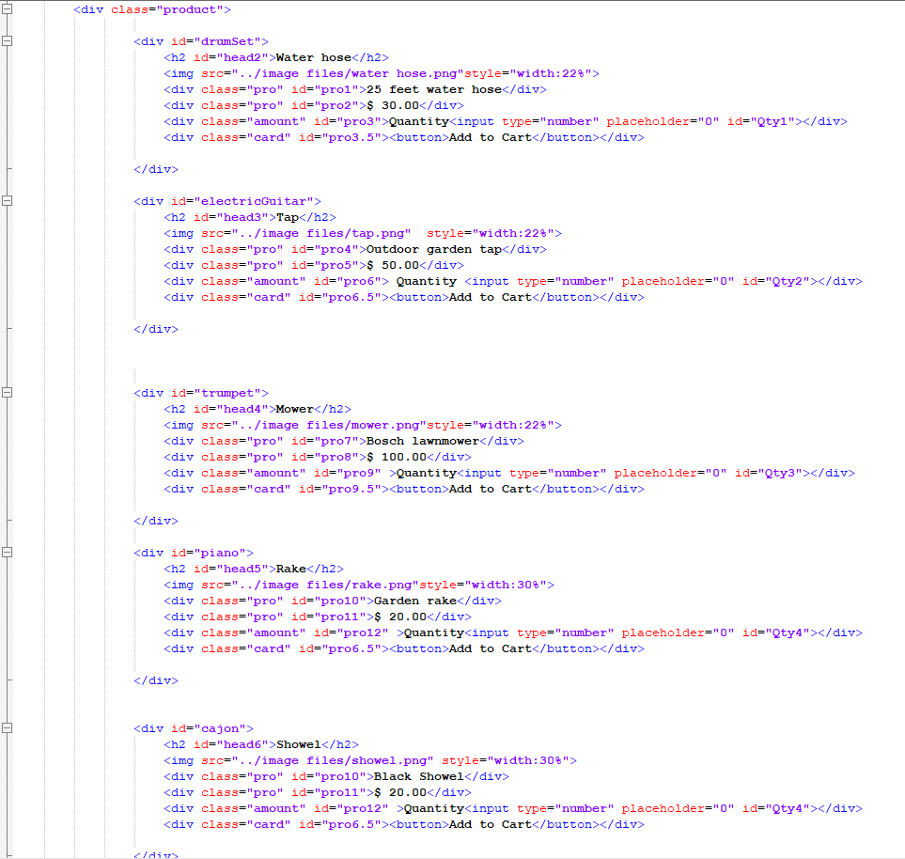Criteria 6 – Home and garden

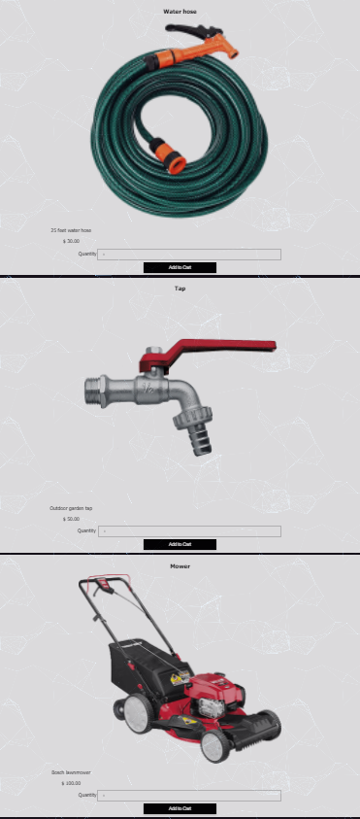

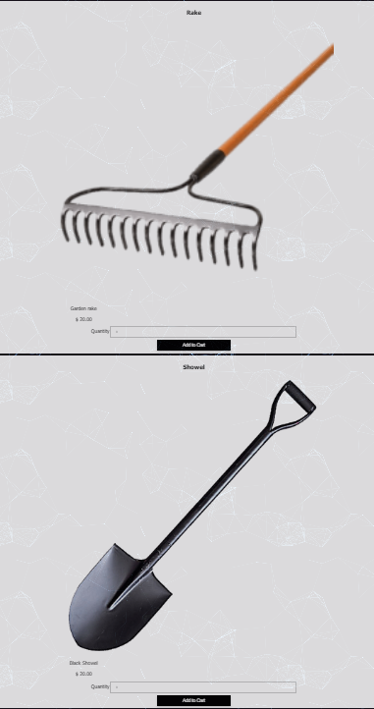

2. A field to claim the points gained from the quiz

Student 3 created 3 copies of purchases html which would represent 5,10,15 discounts for each criteria.

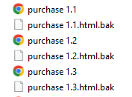

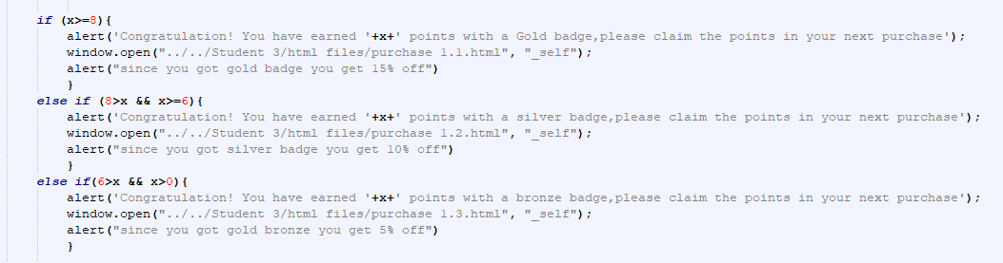then li then linked through quise html.

5. If the compulsory fields are filled-in, when the 'place order' button is clicked, the user should get a

popup window with the summary of the order. For example, the text in the popup window could be

something like: "Dear Anna, you have ordered 1 MonoChrome template at a cost of £20 and 2 Harry

cool templates at a cost of £30. Your total bill is £80

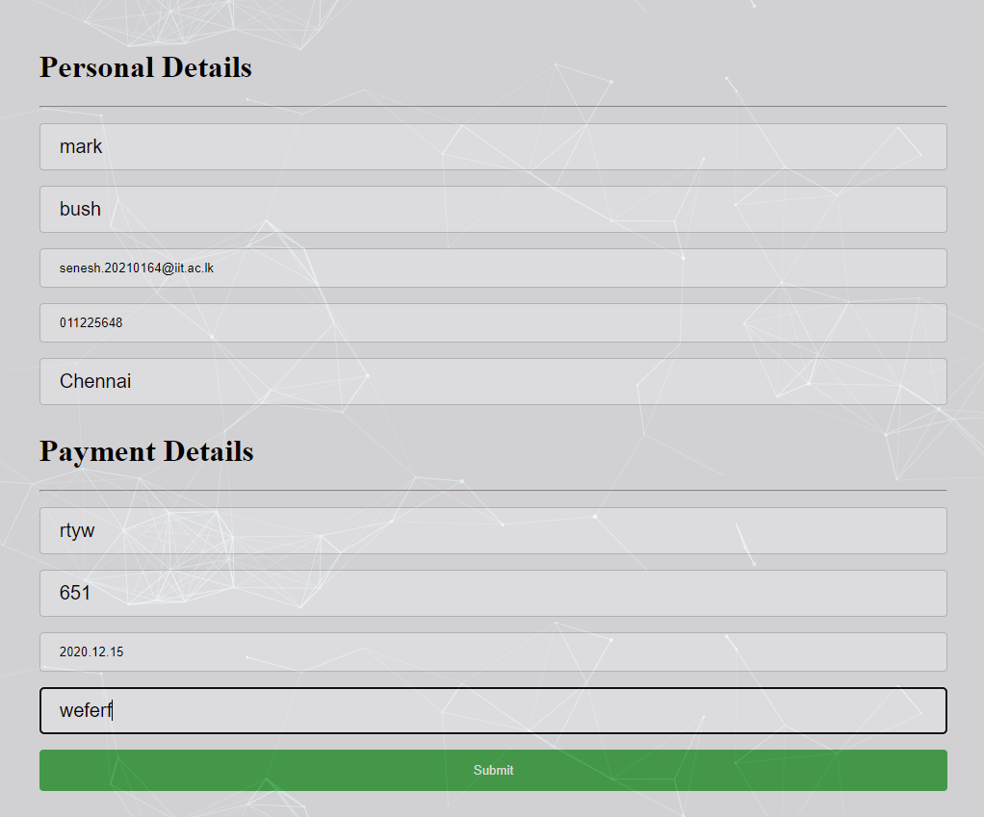

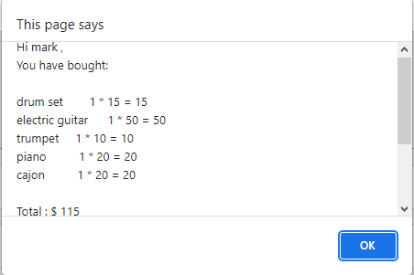

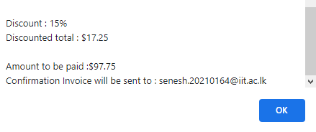

The About Us page contain four pictures of the members of the group. When the user moves the mouse over one picture, the details of that member should be displayed in an area on the page (Eg: you could use a div below the pictures). The details should include the name and role that that student took for the coursework (e.g. John Smith, Student 1).

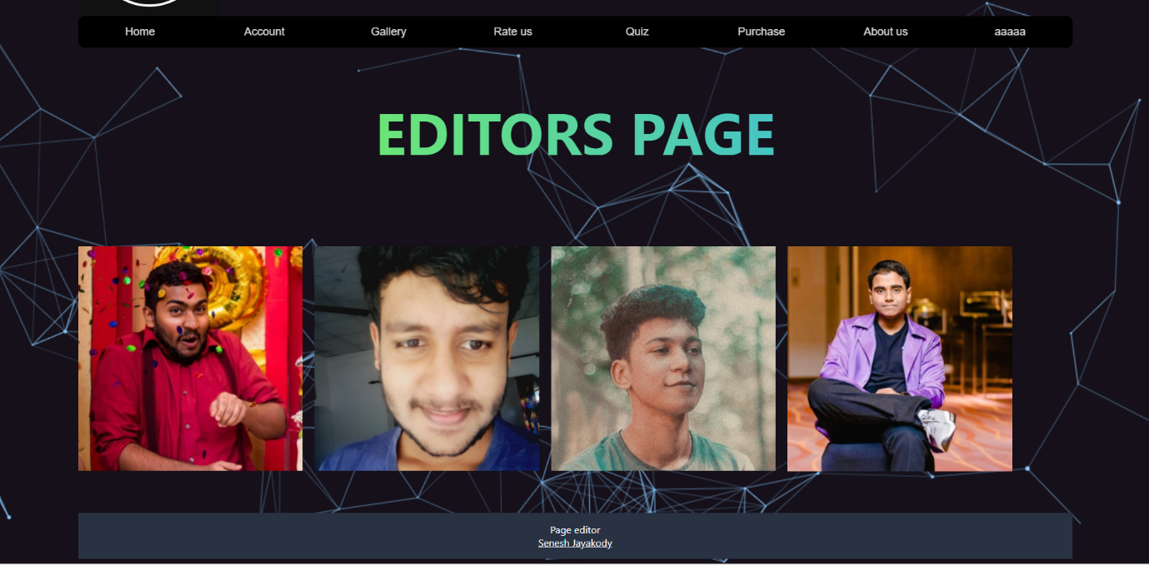

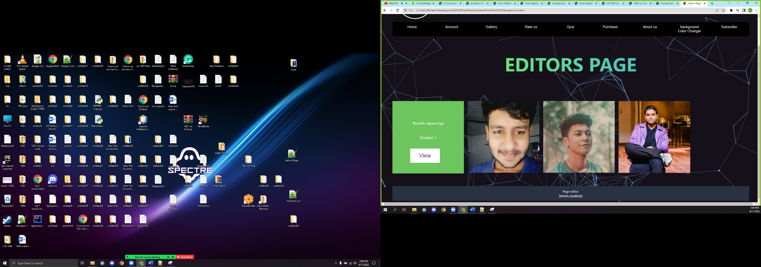

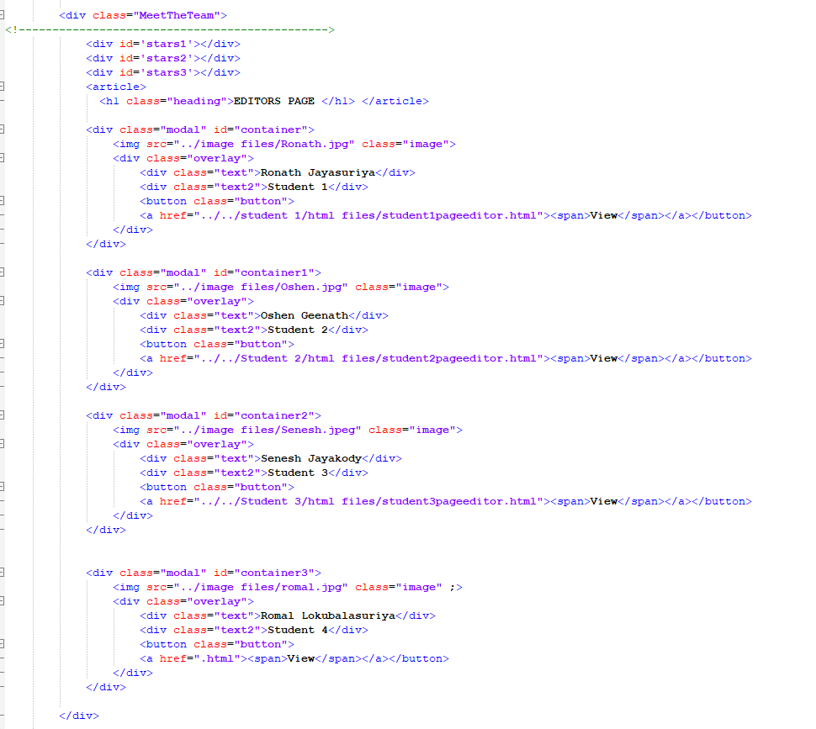

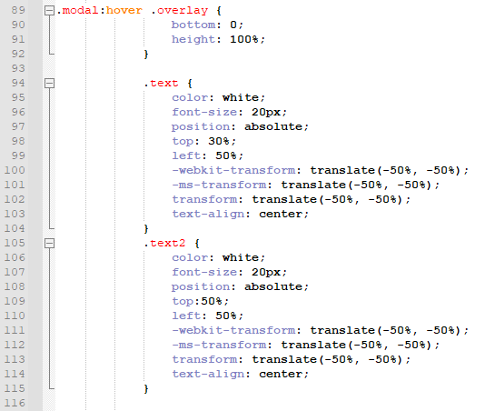Then use css to on mouse hover effect

•Create editors page

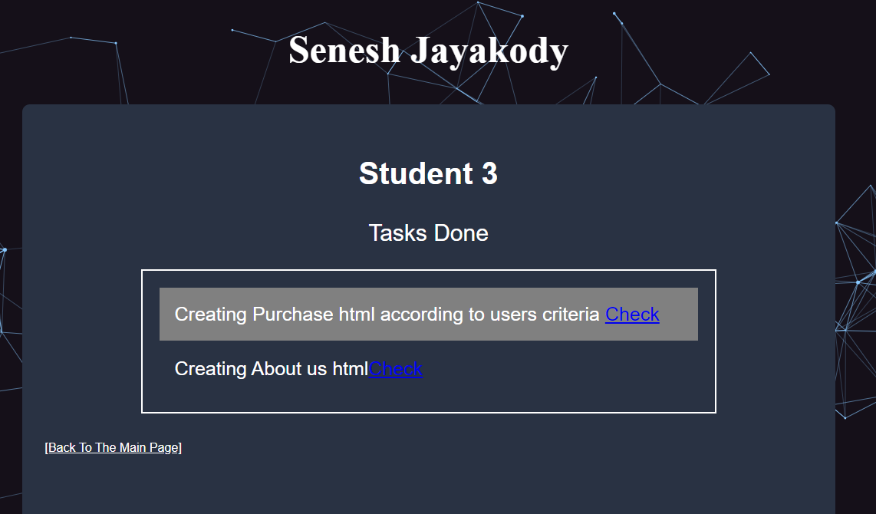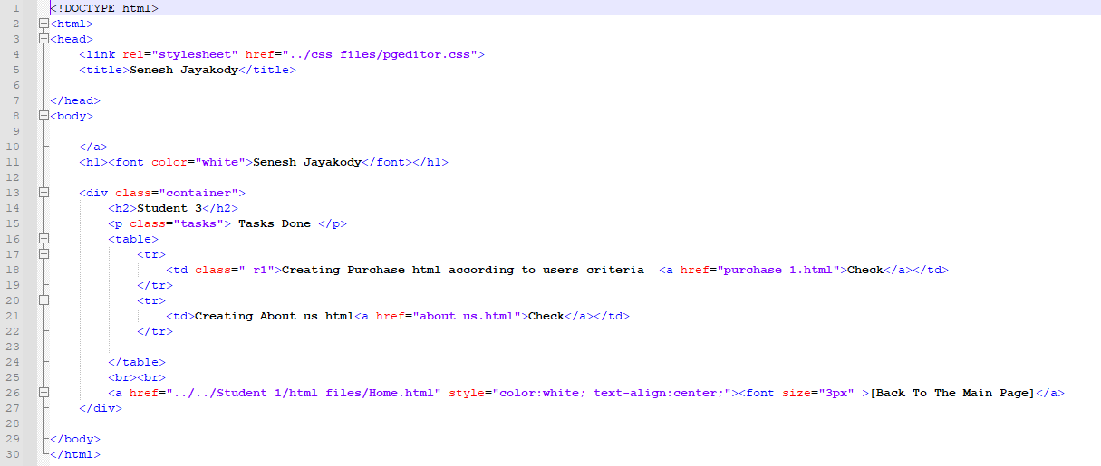Linke d all the websites that I created to the editors page

## Student 04 – Romal Lokubalasuriya

Create a listing page described in the coursework scenarios

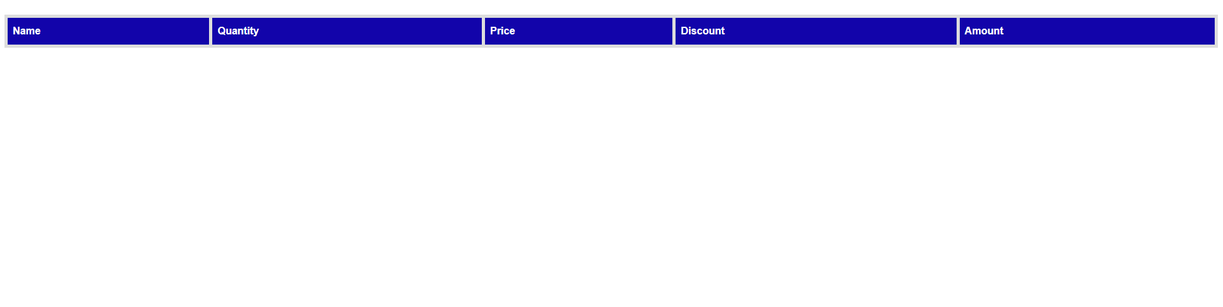

XML used

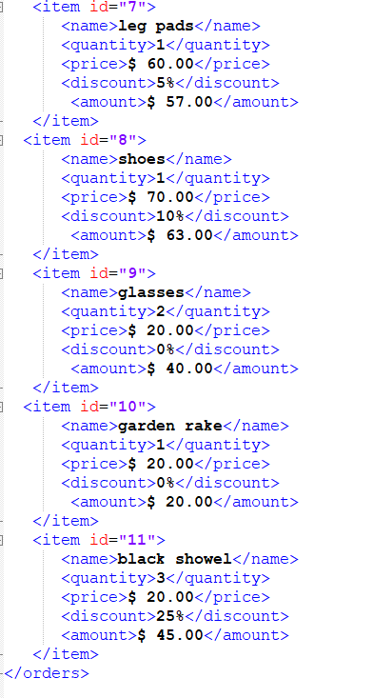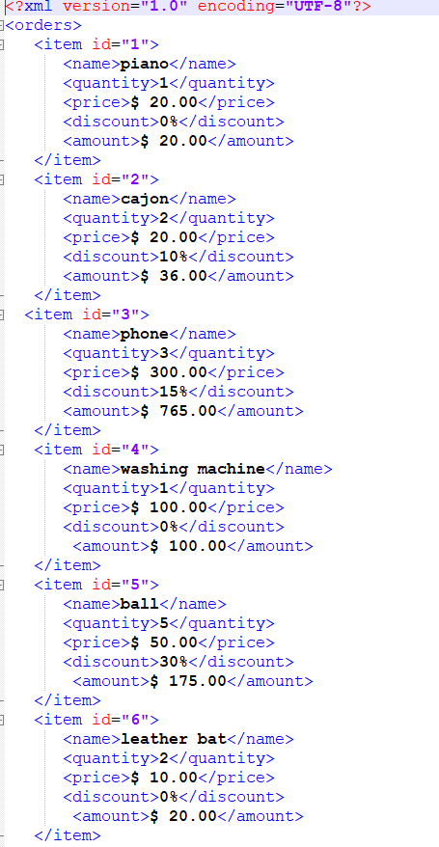

Create JavaScript functionality to change the background and text color of the listing page. (Use pulldown menus

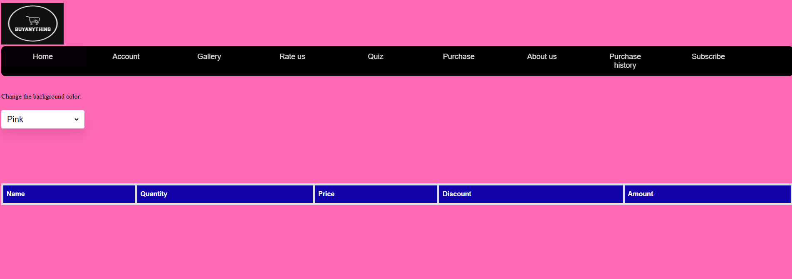

Css used

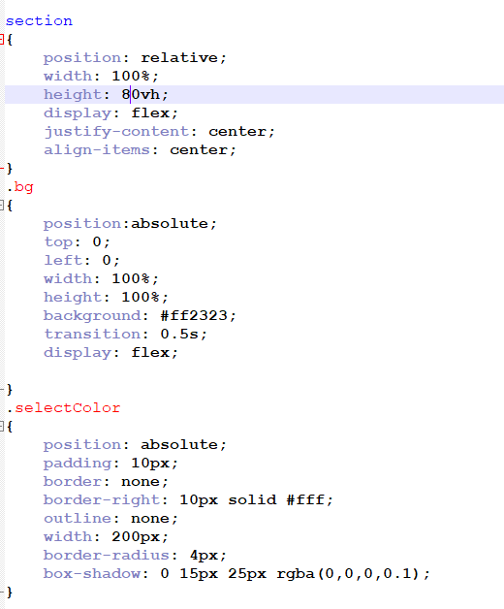

Create an activation form to subscribe for a personalized newsletter

Css used

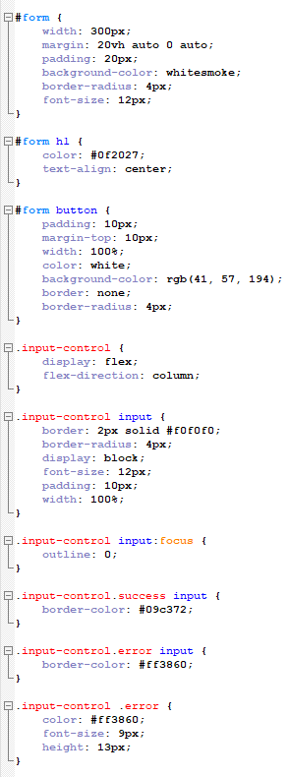

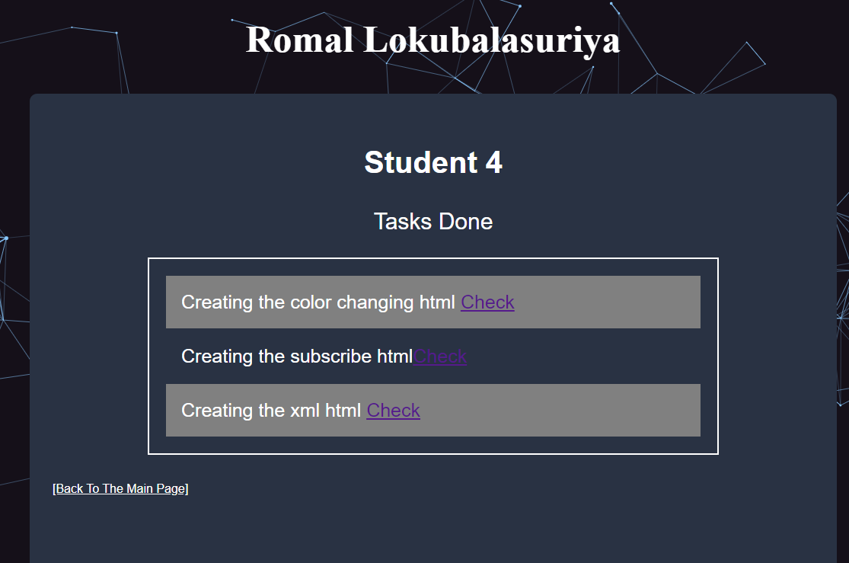

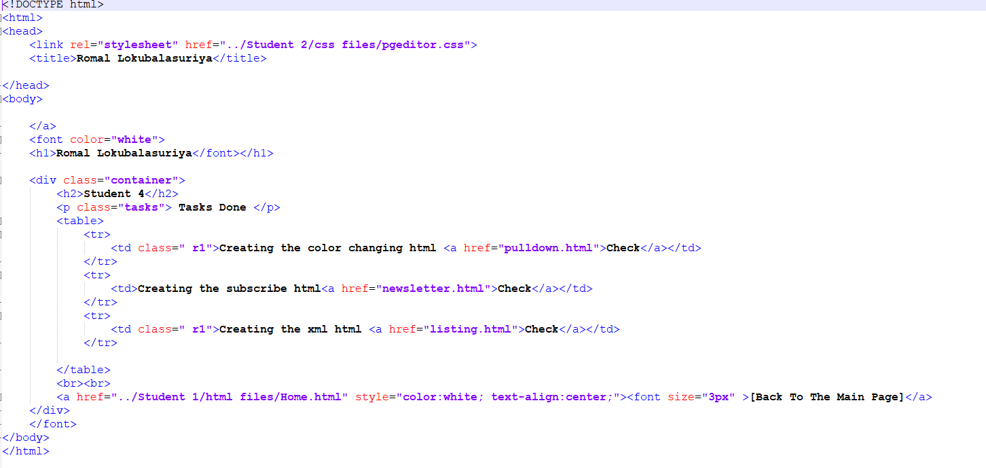

# 4.Discussion of UX/UI principles/Applications/Justifications

## 4.1 Navigation Techniques

 Created a navigation tab which would be changed according to the users selection of criteria

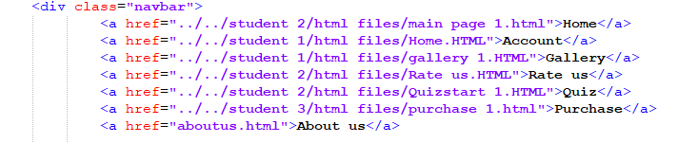

These href links would be changed according to the users criteria selection

Then used css to alter colour when hovering over navigation bar

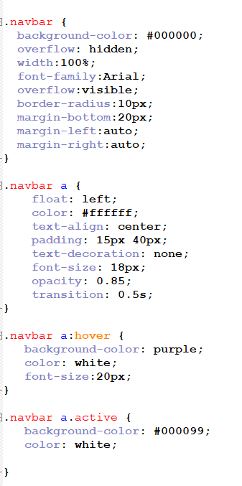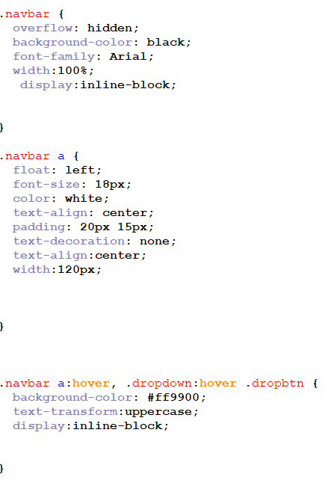The css used

When the user selects a criteria, according to that criteria the main page that relates to that criteria would be opened

SELECTS CRITERA IN ACCOUNT CREATION

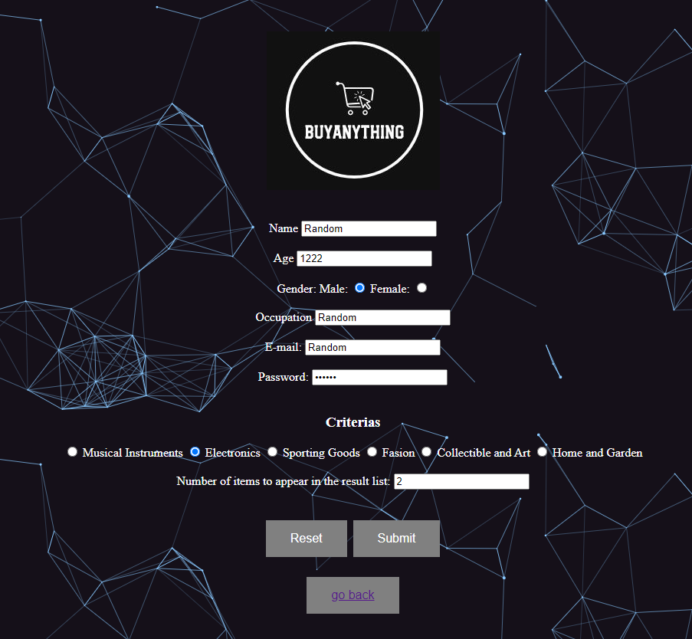

Made a javaScript to launch one of the main page according to the criteria selection

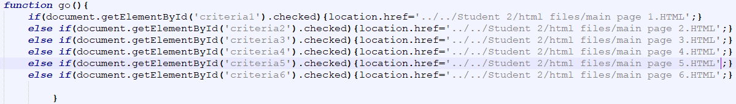

Which would launch one of the files

Student 2 > html files > main page 1

Student 2 > html files > main page 2

Student 2 > html files > main page 3

Student 2 > html files > main page 4

Student 2 > html files > main page 5

Student 2 > html files > main page 6

To get the discount from the quiz

Made the javaScript to launch 1 of the 3 copies of the purchase html which has 15 , 10 and 5 percent discounts

When the user gets a gold badge

Student 3 > html files > purchase 1.1

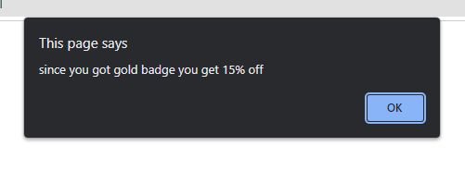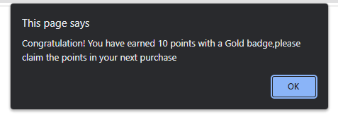 This would be launched when the user enter the goes to buy items

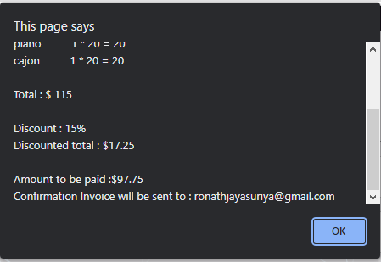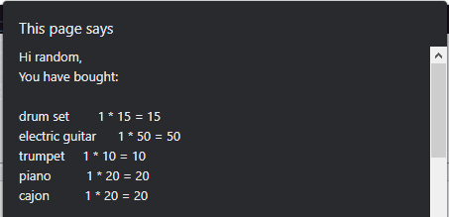



When the user gets a Silver badge

Student 3 > html files > purchase 1.2

This would be launched when the user enter the goes to buy items

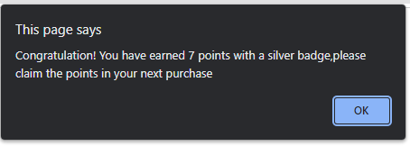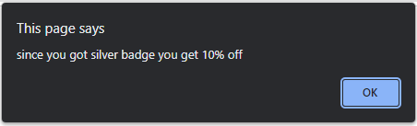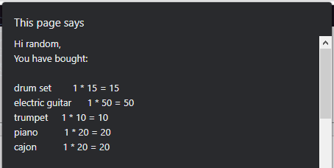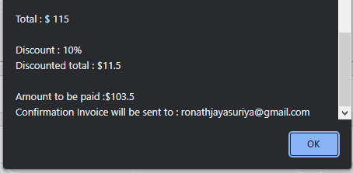



When the user gets a Bronze badge

Student 3 > html files > purchase 1.3

This would be launched when the user enter the goes to buy items

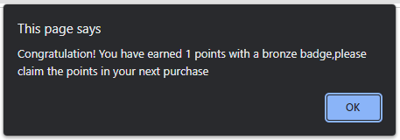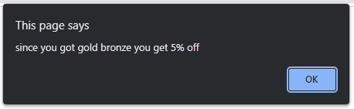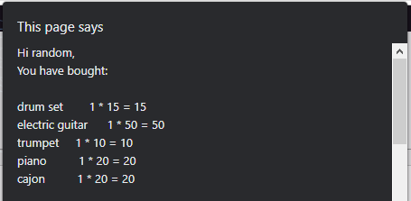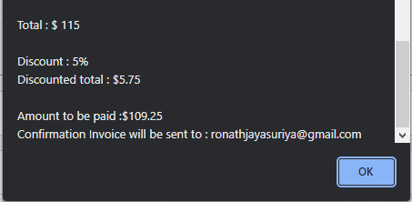



When the user gets a bellow bronze

It would show a link to redirect back to the main menu



## 4.2 Colour balance/selection/consistency

Colours used

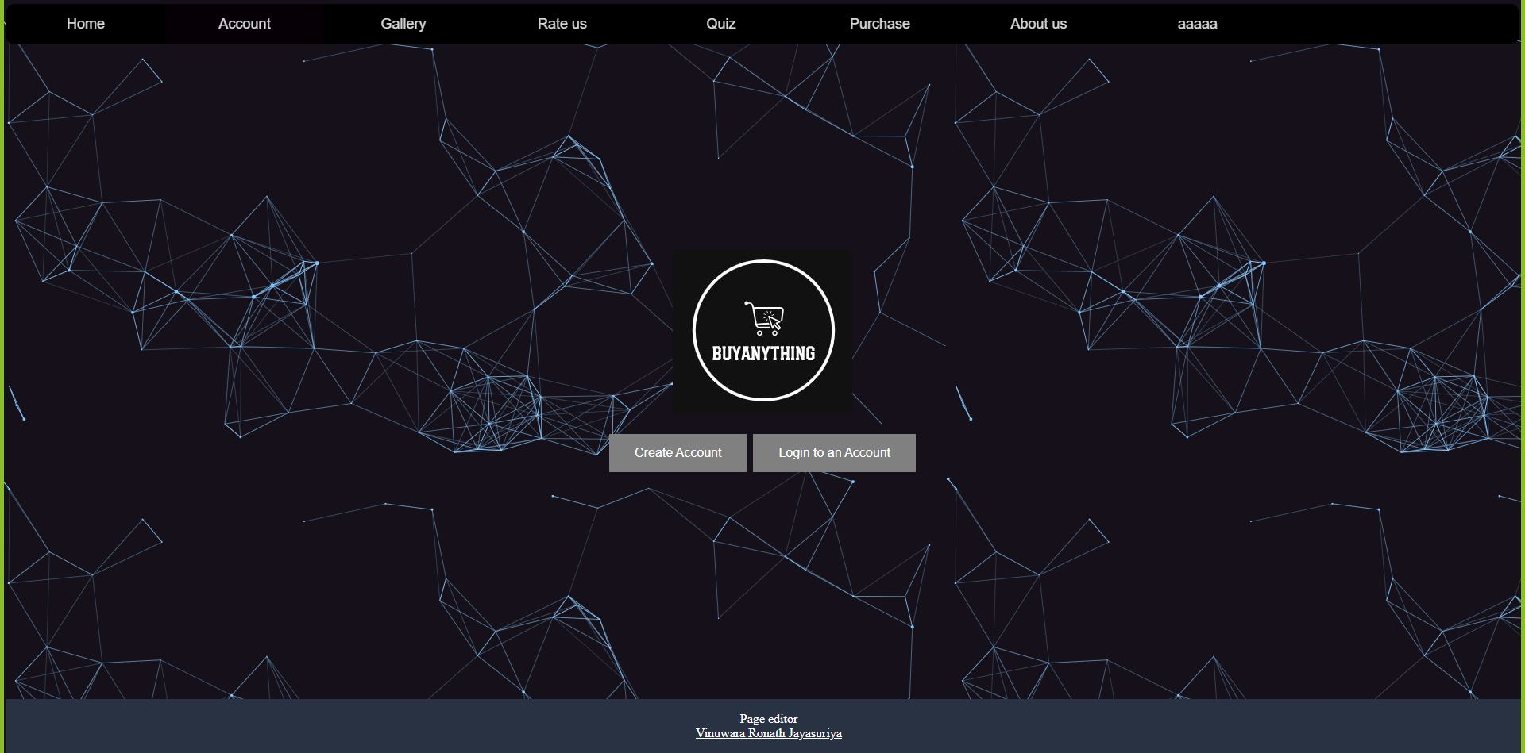

1 2 3 4 5

Number 1 colours was used as the background images main colour which would help to make the font which was in white pop out more.

Background used



Used css

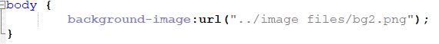

Number 2 was used to represent buttons. Which would be easily visible to the user

Submit buttons

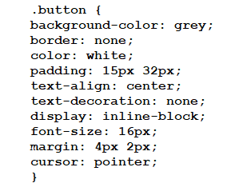

Number 3 was used in navigation tab and the logo which would help to keep the website in same colour scheme



Inserted the image using normal html

Used css

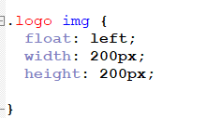



Number 4 was used to highlight navigation tab on mouse hover. Hence it would help the user to see where you was selecting

Css used

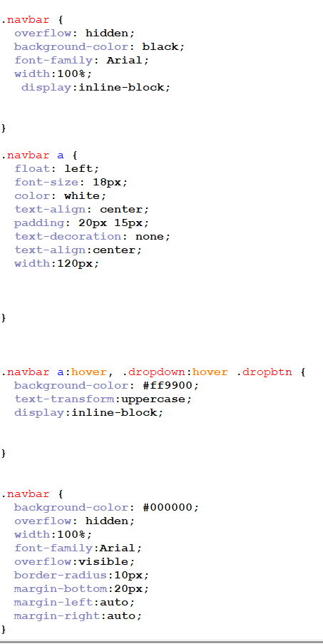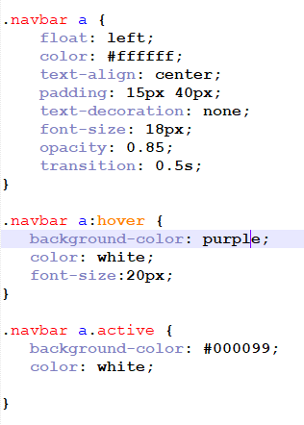

Number 5 was used to represent the submit button in the purchase html

Since the background is white number 2 colour cannot be used. Therefore, to make the button pop out we used green colour.



Css used

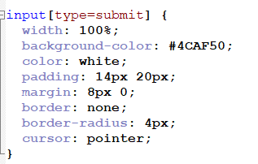

## 4.3 Colour Contrast Test

Purchase html / Account create html / Quiz html /Rate us

Used the same colour scheme

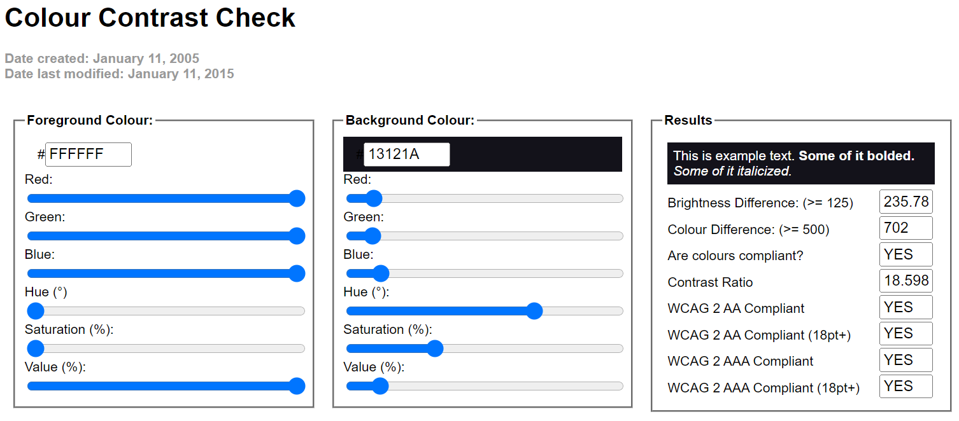

About us page

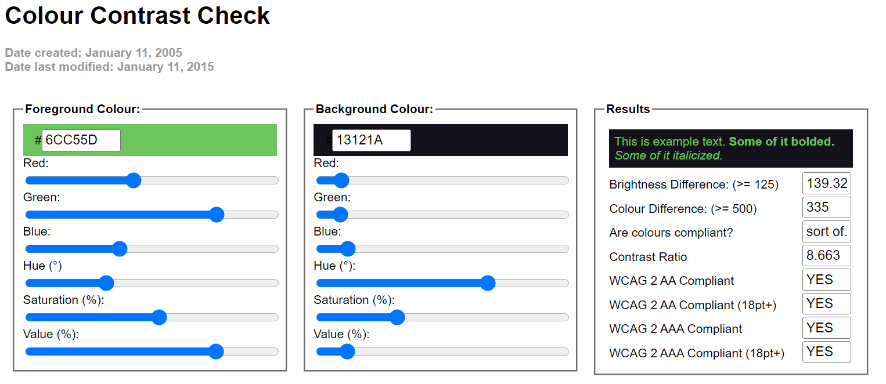

Submit button in create account html

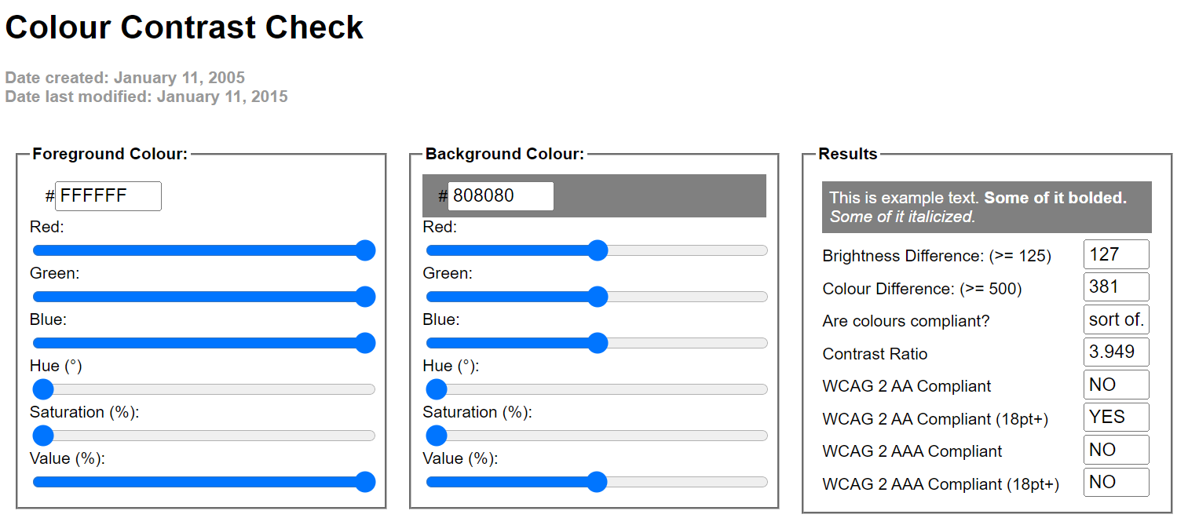

Submit button in purchase html

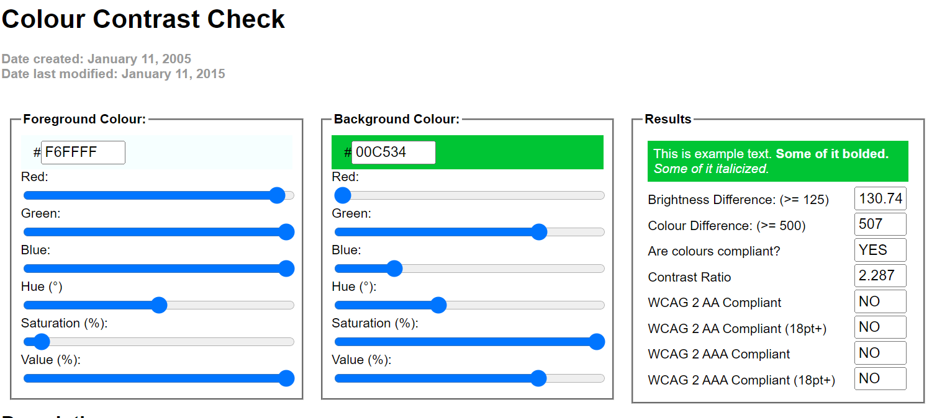

## 4.4 Typography / consistency

Create Account html

* Moved the form to the center to make the website symmetrical using <center> tag
* Change the font color to white to make it pop using <font color=”white”>
* Font type used is arial

Main page html

* There is no font in this website

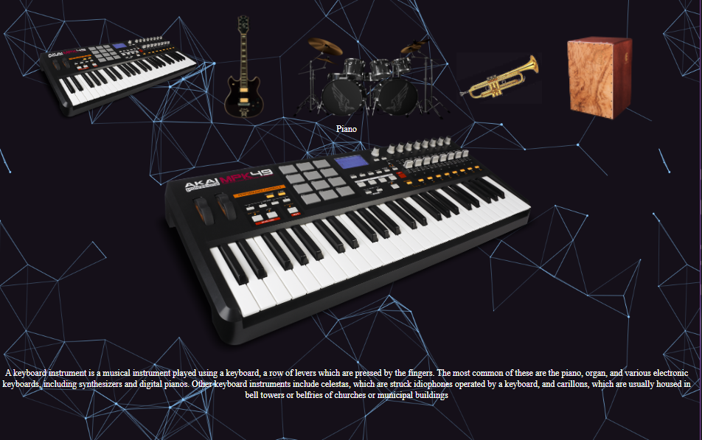Gallery html

* Used white colored font in the html to make it more visible

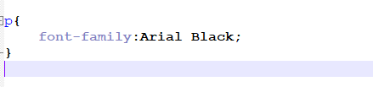

Purchase html

* Used Tahoma font
* Made the font size to 16px
* This makes it more visible

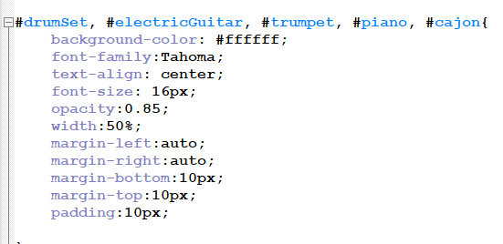

About us page

For buttons ,

Changed the font size

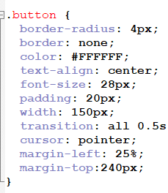

Page editor’s html

Changed font sizes to differentiate titles

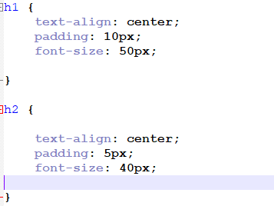

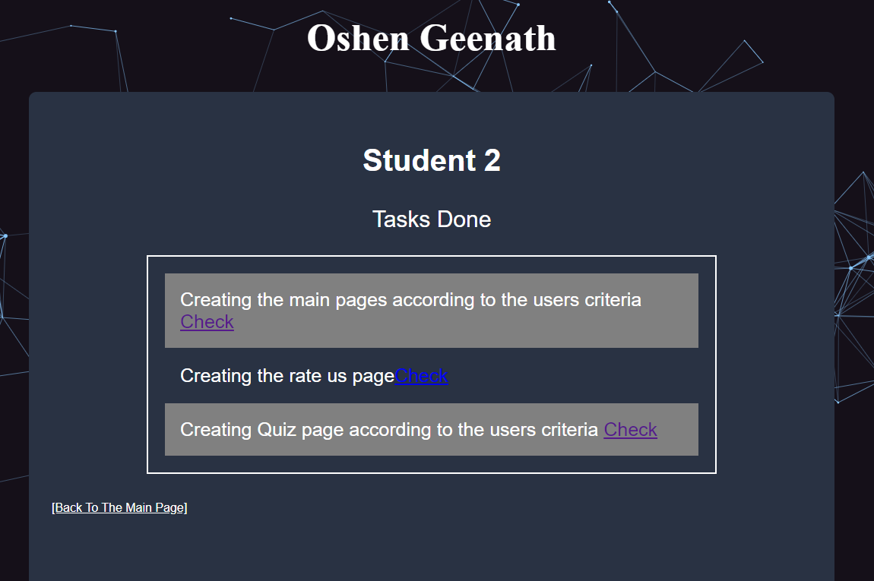

## 4.5 Accessibility

* Image Accessibility Techniques
  + Used alternate text for each image using the alt tag, which would mitigate issues if there’s a problem with the images e

Example: accidentally deleting or losing the image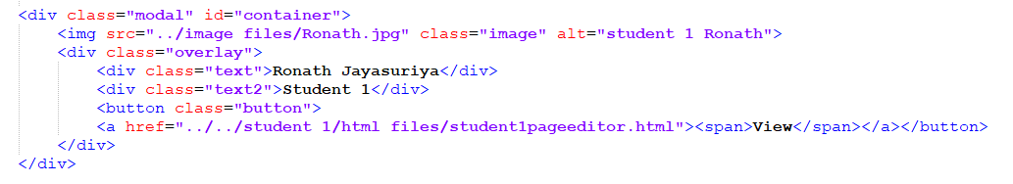

If the image somehow disappears

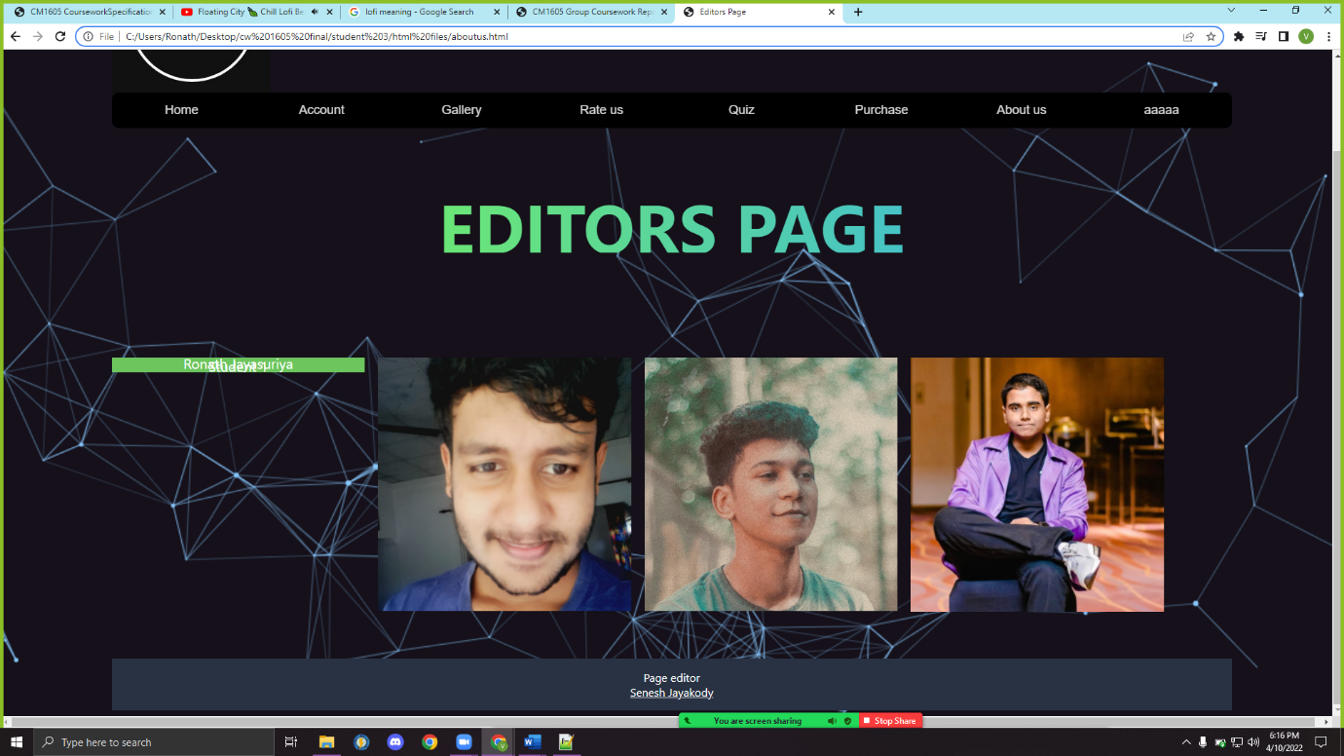

* Form Accessibility Techniques
  + Used label tags around input tags to have better accessibility in all the forms

This helps in writing css codes.

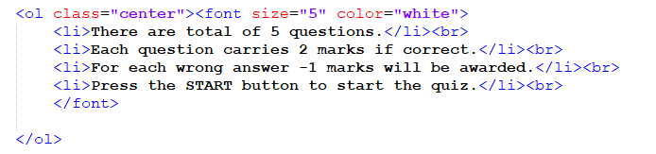example :

Used css to center the list

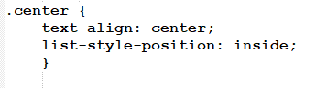

## 4.6 Accessibility Test

(Was unable to run the webpages through the Wave test, as they did not accept the url provided)

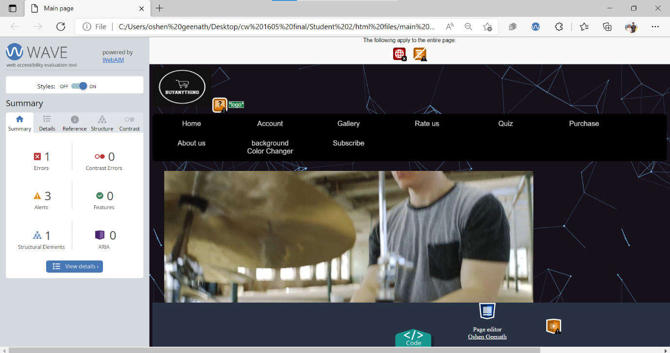Main page

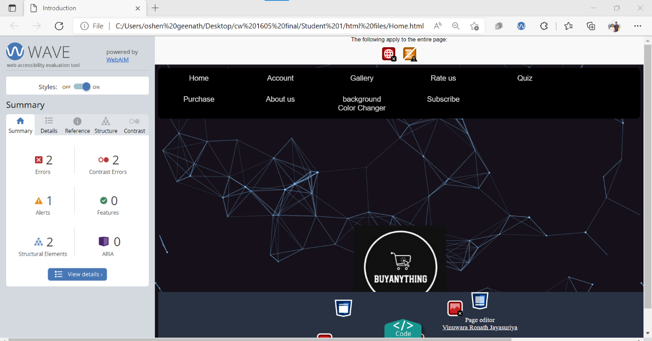Account page

## 4.6 Site Diagram



# 5.Self-Reflection

Vinuwara Ronath Student 1

We did a fantastic job in bringing out our website to life. Our group members met through Zoom and read through the course work specification several times together. After thoroughly discussing the specified requirements, we roughly appointed students to their topics, yet agreed not the make it concrete until the index page was created. Thereafter, we met regular in Zoom and began html coding live online with the others present. This helped us overcome the issue of having to conduct this group activity online.

Oshen Geenath Student 2

Since I live in a remote area and due to blackouts i had connection issues. WeHad to overcome that challenge by utilizing the most amount of time we had to do the course work. At the start of this project, Also it seemed like everyone had their individual task to complete but even though we all had a section assigned to us specifically it was impossible to do it alone. There were so many places where we went wrong and needed help from each other, and this helped us work together to design the website as we had to work collaboratively for it to look best.

Senesh Jayakody Student 3

Even though we stumbled upon several barriers in reaching our goals, including regular power cuts which led to group members staying up at night till the next morning or doing the course work using mobile data and laptops

Romal Lokubalasuriya Student 4

The tasks I handled were a bit challenging due it being xml which I am not confident at.Therefore I had to watch some youtube videos to cover that issue.

# 6.References

W3-Schools tutorials on Html, css and JavaScript for basic knowledge and code any form of new

Youtube (2022). *YouTube*. *YouTube*. Available at: <https://www.youtube.com/>.

W3Schools (2019). *HTML Tutorial*. [online] W3schools.com. Available at: <https://www.w3schools.com/html/default.asp>.

GeeksforGeeks. (2019). *GeeksforGeeks | A computer science portal for geeks*. [online] Available at: <https://www.geeksforgeeks.org/>.

Zoom (2021). *Video Conferencing, Web Conferencing, Webinars, Screen Sharing*. [online] Zoom Video. Available at: <https://zoom.us/>.

eBay (2019). *Electronics, Cars, Fashion, Collectibles, Coupons and More | eBay*. [online] eBay. Available at: <https://www.ebay.com/>.

www.daraz.lk. (n.d.). *Online Shopping Sri Lanka: Clothes, Electronics & Phones | Daraz.lk*. [online] Available at: [https://www.daraz.lk/#](https://www.daraz.lk/).

‌

# 7.Appendix

Index html

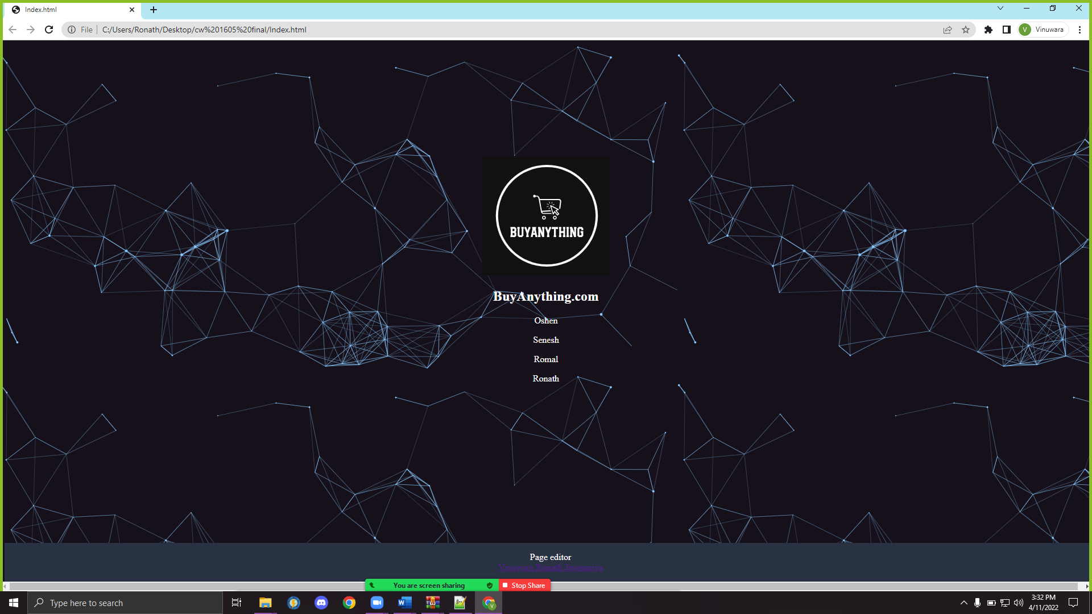

Account Home page

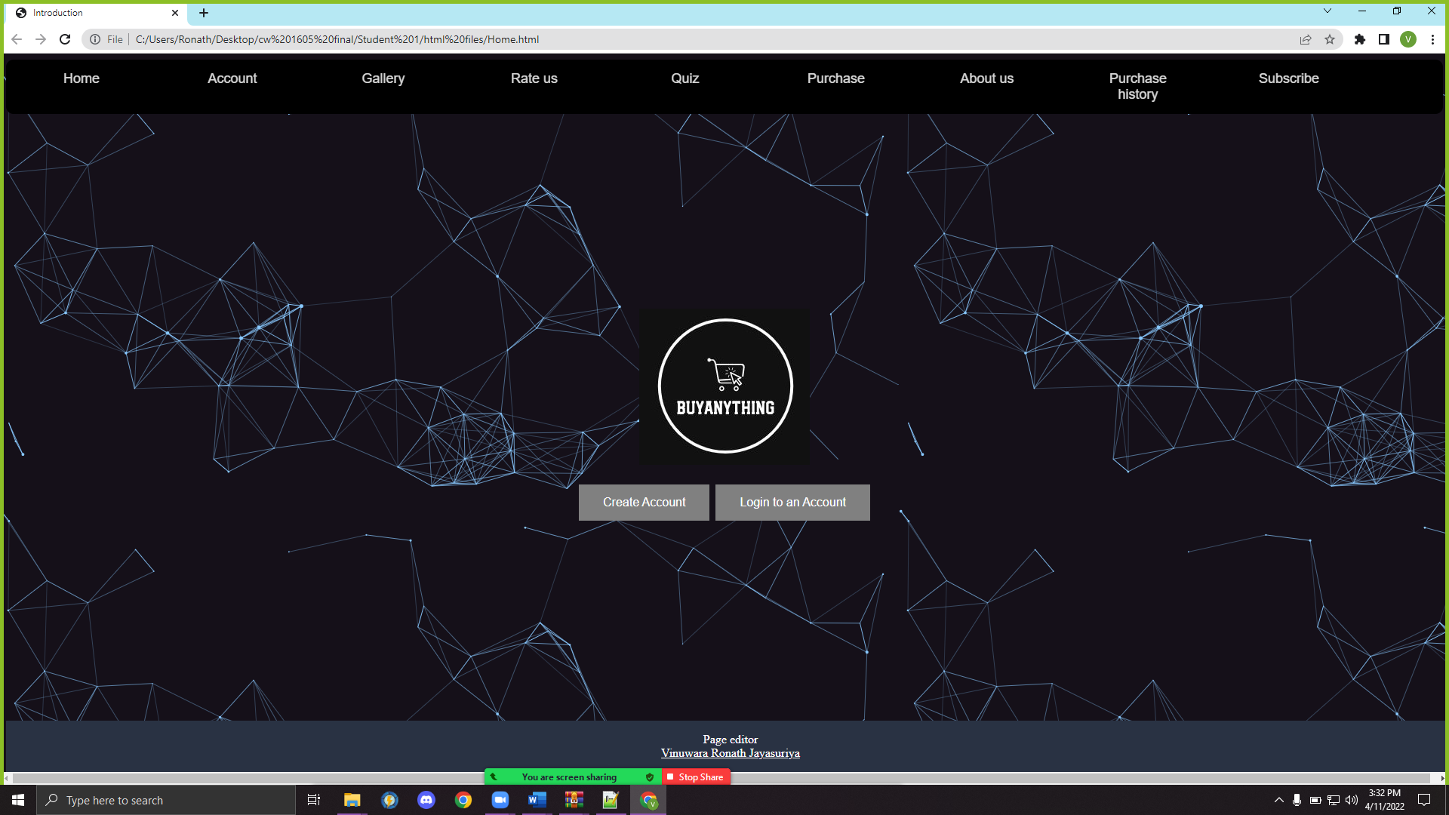

Create Account

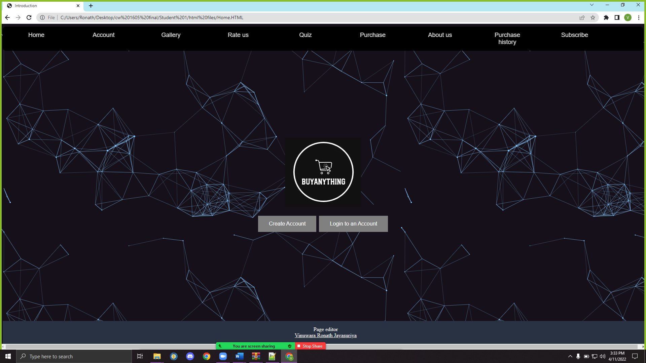

Create account

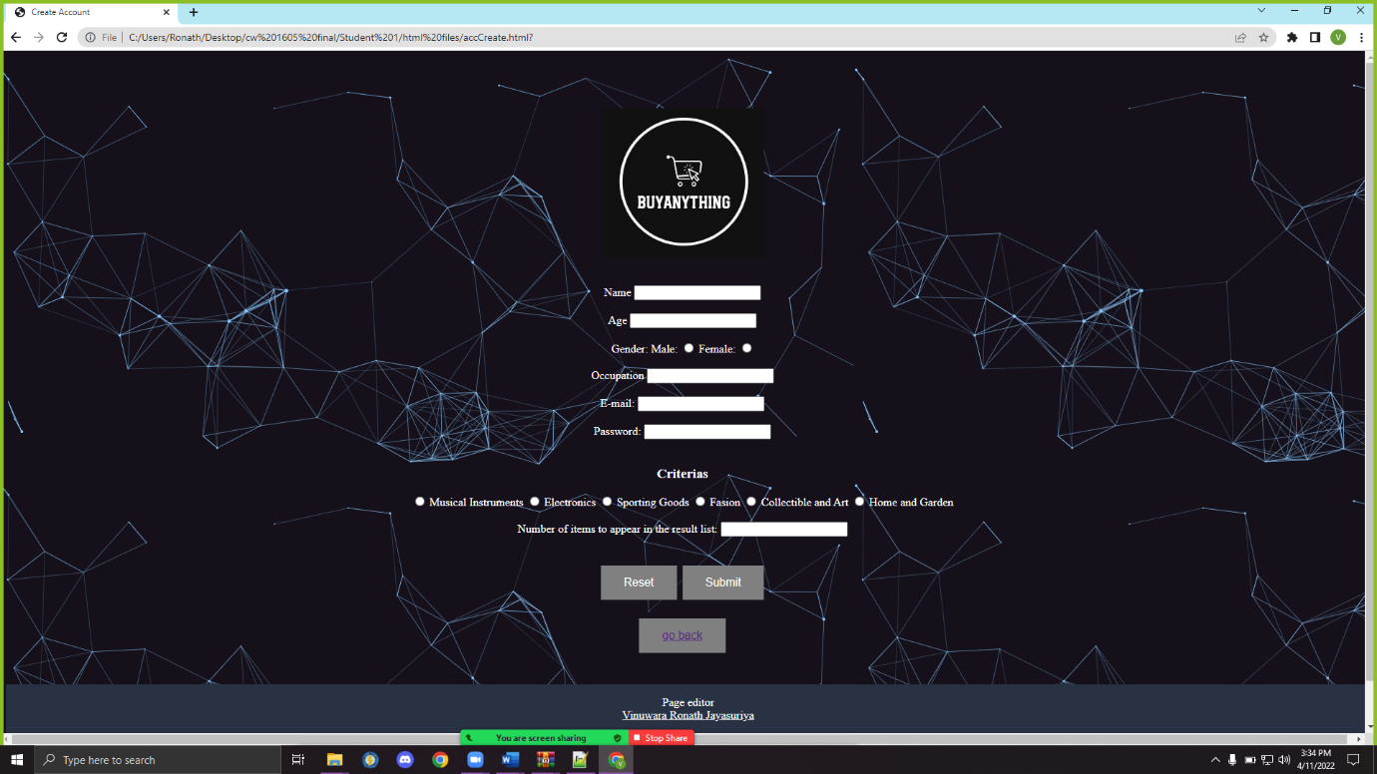

Main Page

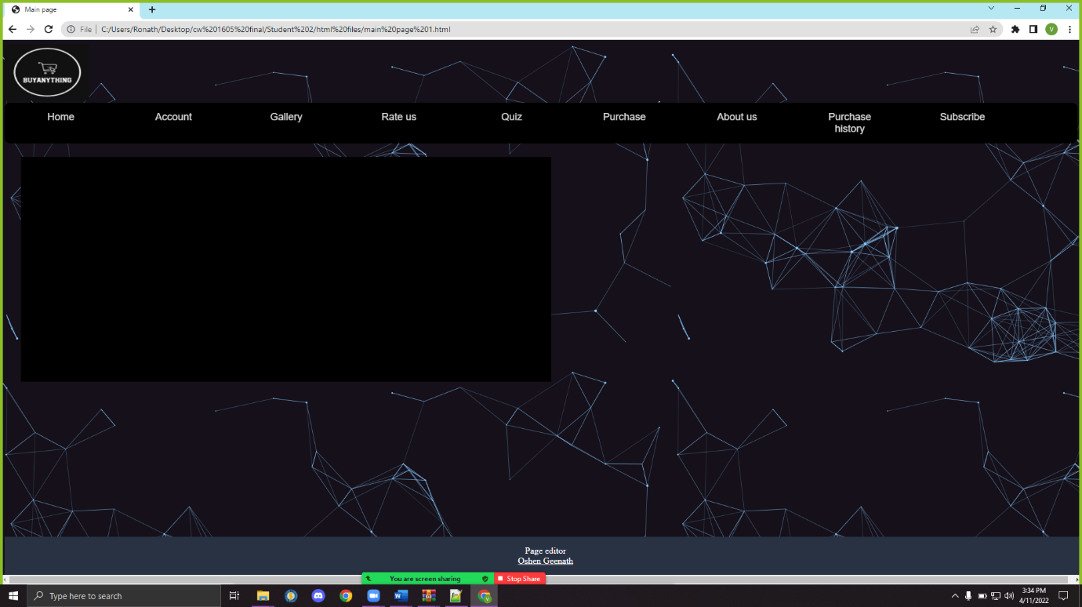

Gallery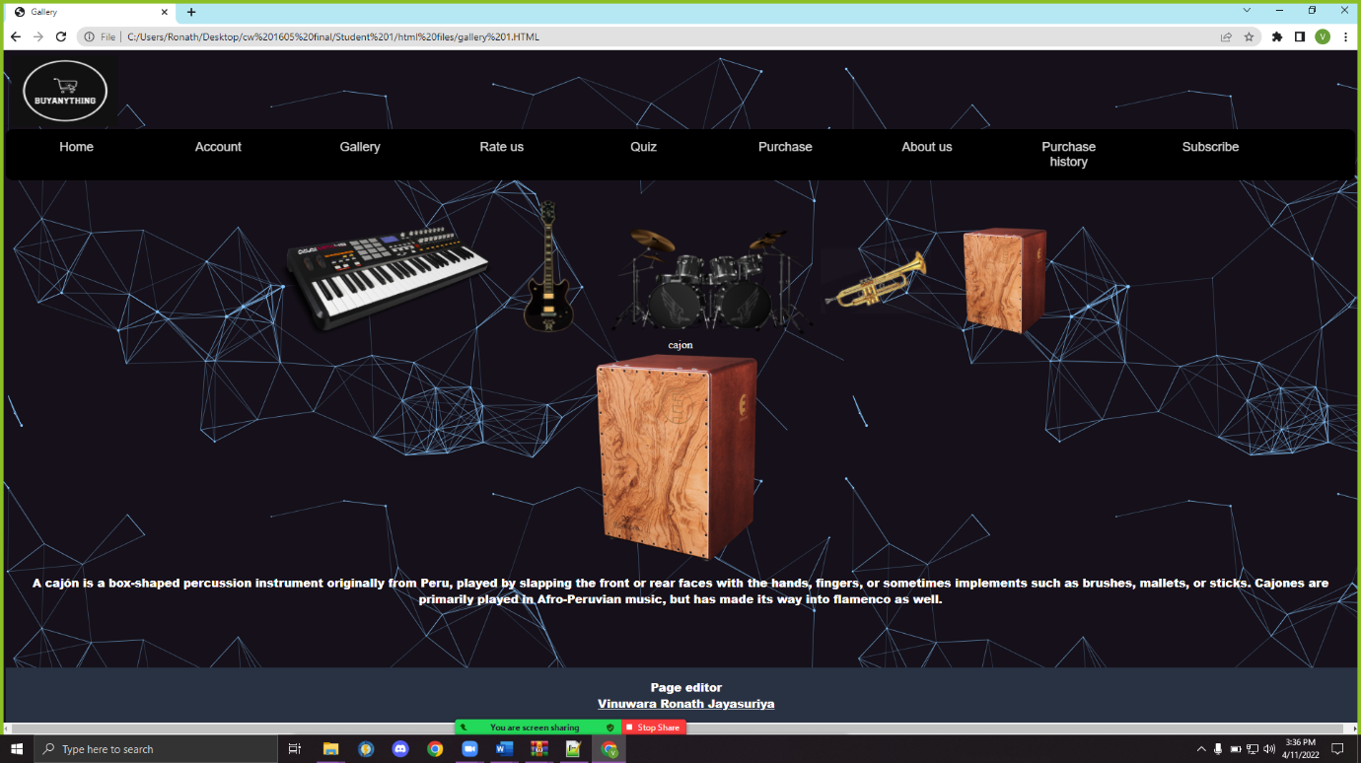

Rate us

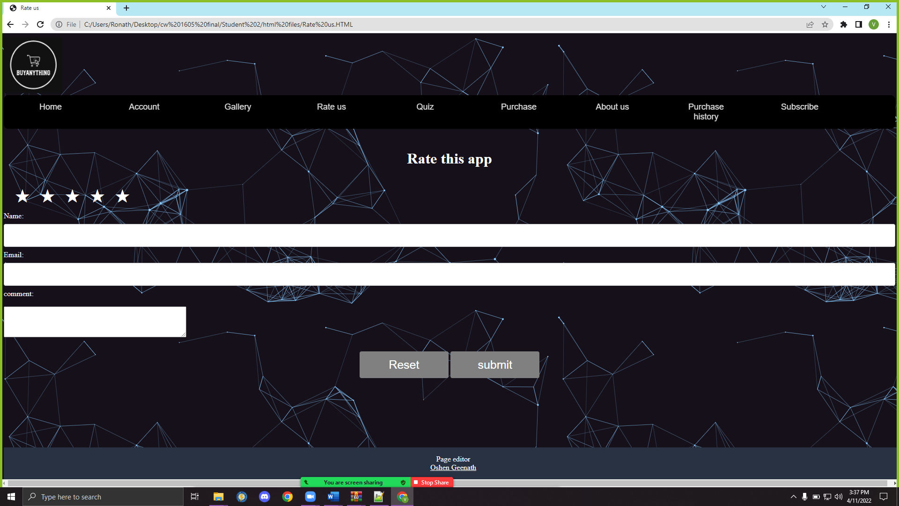

Quiz

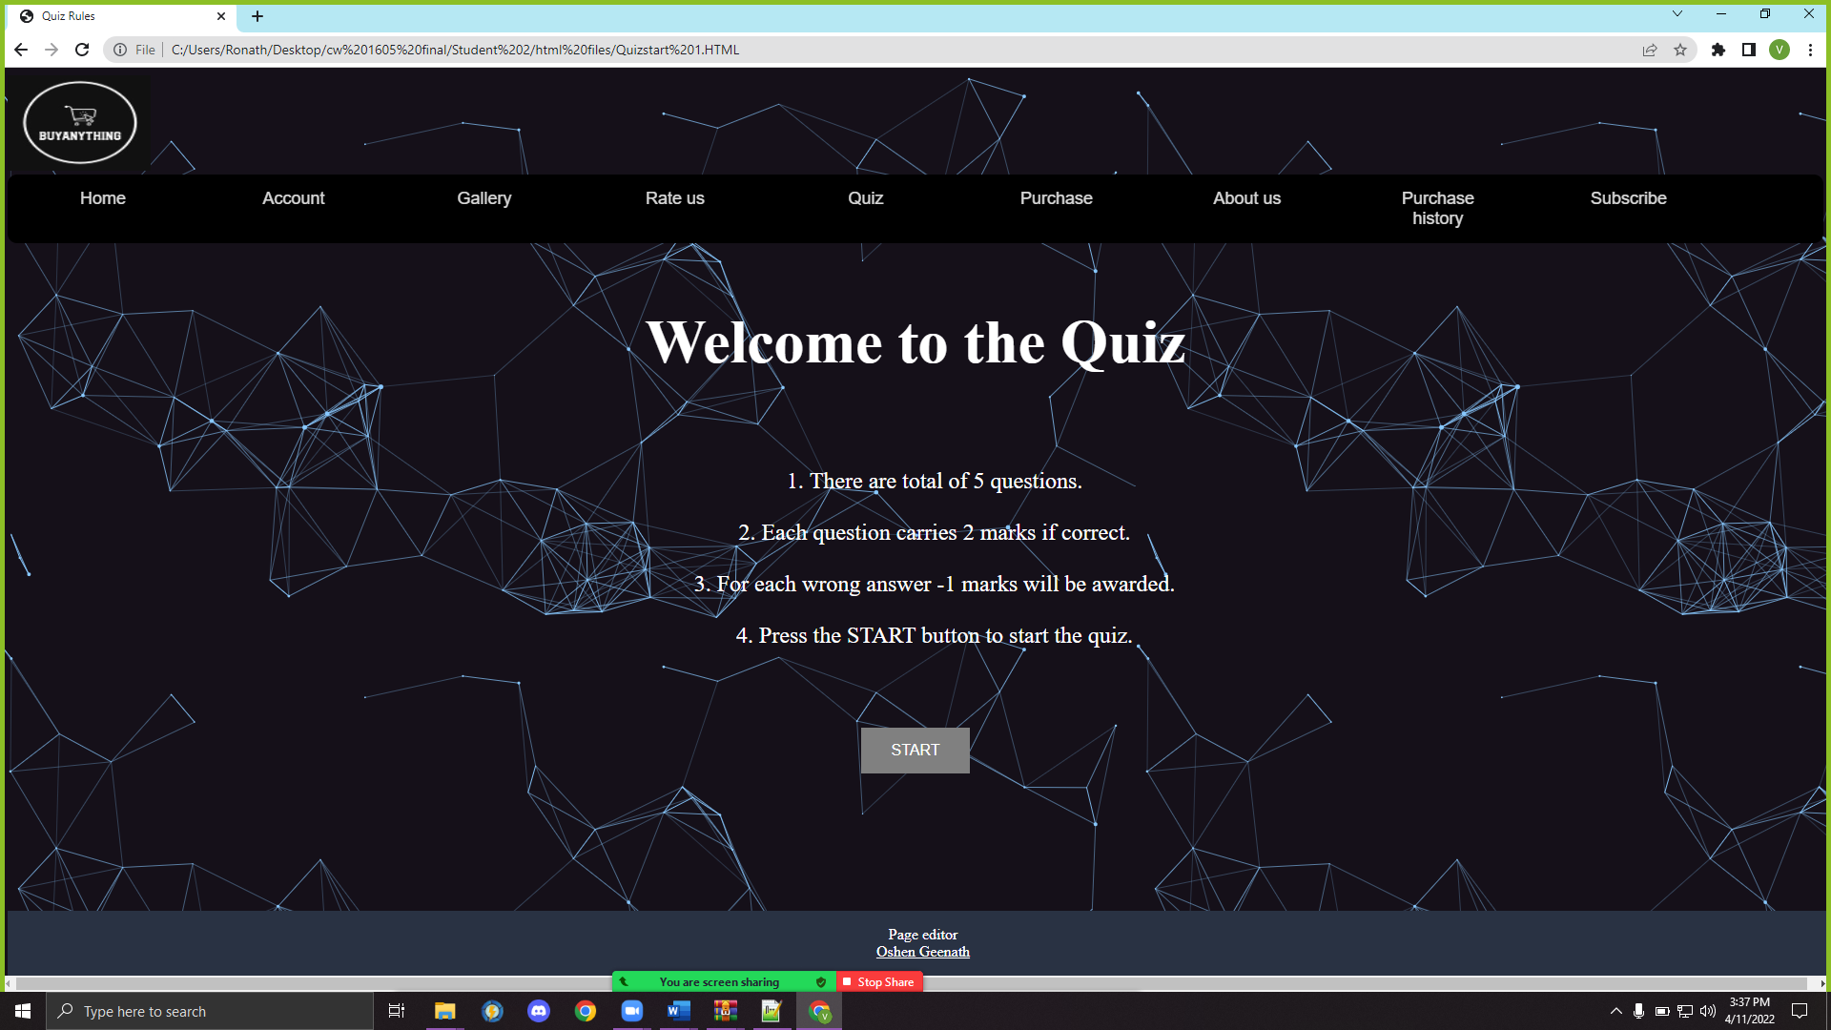

Purchase

